Project
RECRUITMENT Section

centre for Industrial consultancy & sponsored research

iNTRODUCTION

Project Staff Recruitment:
The Projects can have the staff appointed by any of the procedures given below:
1. Staff appointed based on regular adverisement and selection
2. Staff appointed on adhoc basis
3. Staff appointed on part time basis
4. Institute Staff engaged for specific tasks
Student employed on part-time basis:
Facility exists to utilize students for specific works in projects. Remuneration is payable to each category of students, provided they do not get fellowship / scholarship from the Institute. The claim shall be made in the prescribed format.
Institute staff engaged for specific tasks:
Institute staff can be engaged for specific tasks in the project outside the normal Institute working hours. The claim for payment is to be made in the prescribed form available in IC & SR.

2. LIST OF TABLES USED FOR RECRUITMENT Section

DATABASE – RECRUIT (Total Size – 334 MB)

AMEETING - Commit Meeting Table

CHADE - Commit Member Table

COORCOD - Coordinators Details Table

COORD - Delivery Details Table

DEPT - Department Table

DESIG - Designation Details Table

DESGINA - Designation Details Table

NEWADH - Adhoc Details Table

NEWREG - Selection Details Table

OFFER - Offer Details Table

PARAMS - Counting Details Table

PART - Part Time Details Table

RLFADH - Relived Adhoc Table

RLFREG - Relived Selection Table

RLPART - Relived Part Time Table

STAFFDATA - Staff Details Table

TMPSERVICE4 - Temporary Table

TMPCOMMITTEE1 - Temporary Table

(Foxoffice -Office section Database)

PCMASTER - Consultancy Master Table

PMASTER - Sponsored Master Table

1. AMEETING COMMIT MEETING TABLE

S.NO | NAME | TYPE | LENGTH
1 | MEETID | nvarchar | 10
2 | DESIGN | nvarchar | 50
3 | MEETDATE | datetime | 8
4 | PROJECTNO | nvarchar | 25
5 | TITLE | nvarchar | 100
6 | AGENCY | nvarchar | 5
7 | COO | nvarchar | 35
8 | CLDATE | nvarchar | 30
9 | FUNDSPOS | nvarchar | 30
10 | DEPARTMENT | nvarchar | 35
11 | CANDNAME | nvarchar | 40
12 | QUALI | nvarchar | 50
13 | EXPERI | nvarchar | 70
14 | AGELIMIT | nvarchar | 30
15 | DOB | datetime | 8
16 | DINP | varchar | 10
17 | FROMDATE | nvarchar | 30
18 | TODATE | nvarchar | 30
19 | PAY | float | 8
20 | PART | nvarchar | 15
21 | PTIME | nvarchar | 20
22 | DINP1 | datetime

2. CHADE Commit Member Table
S.NO | NAME | TYPE | LENGTH
1 | NAME | nvarchar | 50
2 | DEPT | nvarchar | 50
3 | DESI | nvarchar | 30
4 | [NO] | nvarchar | 10

3. COORCOD Coordinators Details Table
S.NO | NAME | TYPE | LENGTH
1 | COOR_CODE | nvarchar | 4
2 | COOR_NAME | nvarchar | 40
3 | DEPARTMENT | nvarchar | 3

4. COORD Delivery Details Table
S.NO | NAME | TYPE | LENGTH
1 | COCODE | nvarchar | 8
2 | NAME | nvarchar | 40
3 | STATUS | nvarchar | 1
4 | STADESP | nvarchar | 20

5. DEPT Department Table
S.NO | NAME | TYPE | LENGTH
1 | DEPCODE | nvarchar | 3
2 | DEPTNAME | nvarchar | 50
3 | HOD_NAME | nvarchar | 30
4 | DEPT | nvarchar | 3

6. DESIG Designation Details Table
S.NO | NAME | TYPE | LENGTH
1 | DESCOD | nvarchar | 4
2 | DESIGN | nvarchar | 30

7. DESGINA Designation Details Table
S.NO | NAME | TYPE | LENGTH
1 | DESCOD | nvarchar | 3
2 | DESIGN | nvarchar | 50
3 | CURDESI | nvarchar | 1
4 | DESORDER | nvarchar | 3

8. NEWADH Adhoc Details Table
S.NO | NAME | TYPE | LENGTH
1 | EMPCODE | nvarchar | 5
2 | STAT | nvarchar | 1
3 | TITLE | nvarchar | 120
4 | PROJECTNO | nvarchar | 25
5 | PTYPE | nvarchar | 2
6 | NAME | nvarchar | 100
7 | DEPT | nvarchar | 4
8 | SPON | nvarchar | 4
9 | DESIG | nvarchar | 3
10 | DTAP | smalldatetime | 4
11 | EXTN | smalldatetime | 4
12 | DRLF | smalldatetime | 4
13 | BASIC | float | 8
14 | INCR | float | 8
15 | DINC | smalldatetime | 4
16 | LDINC | smalldatetime | 4
17 | COOR | nvarchar | 4
18 | REM | nvarchar | 20
19 | SCSTOS | nvarchar | 2
20 | FILENO | nvarchar | 6
21 | OLD_FILENO | nvarchar | 6
22 | DESIGN | nvarchar | 35
23 | COO | nvarchar | 60
24 | PFLAG | nvarchar | 1
25 | HRA | float | 8
26 | DT_INP | smalldatetime | 4
27 | DT_CHG | smalldatetime | 4
28 | PCODE | nvarchar | 30
29 | DOB | smalldatetime | 4
30 | DEPARTMENT | nvarchar | 40
31 | FATHER | nvarchar | 30
32 | ADDRESS1 | nvarchar | 30
33 | ADDRESS2 | nvarchar | 30
34 | ADDRESS3 | nvarchar | 30
35 | ADDRESS4 | nvarchar | 30
36 | CITY | nvarchar | 20
37 | [MONTH] | float | 8
38 | RATE | float | 8
39 | SEX | nvarchar | 1
40 | BLDGRP | nvarchar | 3
41 | RH | nvarchar | 3
42 | PHONE | nvarchar | 4
43 | R_ADDR1 | nvarchar | 30
44 | R_ADDR2 | nvarchar | 30
45 | R_CITY | nvarchar | 20
46 | R_PIN | nvarchar | 7
47 | R_PHONE | nvarchar | 12
48 | R_ADDR3 | nvarchar | 30
49 | R_ADDR4 | nvarchar | 30
50 | COURSE | nvarchar | 10
51 | SEMESTER | nvarchar | 20
52 | YR | char | 4
53 | PROVISIONAL | datetime | 8
54 | MEDICAL | nvarchar | 10
55 | EXTN_DATE | datetime | 8

9. NEWREG Selection Details Table
S.NO | NAME | TYPE | LENGTH
1 | EMPCODE | nvarchar | 5
2 | STAT | nvarchar | 1
3 | TITLE | nvarchar | 120
4 | PROJECTNO | nvarchar | 25
5 | PTYPE | nvarchar | 2
6 | NAME | nvarchar | 100
7 | DEPT | nvarchar | 3
8 | SPON | nvarchar | 4
9 | DESIG | nvarchar | 3
10 | DTAP | smalldatetime | 4
11 | EXTN | smalldatetime | 4
12 | DRLF | smalldatetime | 4
13 | BASIC | float | 8
14 | INCR | float | 8
15 | DINC | smalldatetime | 4
16 | LDINC | smalldatetime | 4
17 | COOR | nvarchar | 4
18 | REM | nvarchar | 20
19 | SCSTOS | nvarchar | 2
20 | FILENO | nvarchar | 6
21 | OLD_FILENO | nvarchar | 6
22 | DESIGN | nvarchar | 35
23 | COO | nvarchar | 50
24 | PFLAG | nvarchar | 1
25 | HRA | float | 8
26 | DT_INP | smalldatetime | 4
27 | DT_CHG | smalldatetime | 4
28 | PCODE | nvarchar | 30
29 | DOB | smalldatetime | 4
30 | DEPARTMENT | nvarchar | 40
31 | FATHER | nvarchar | 30
32 | ADDRESS1 | nvarchar | 30
33 | ADDRESS2 | nvarchar | 30
34 | ADDRESS3 | nvarchar | 30
35 | ADDRESS4 | nvarchar | 30
36 | CITY | nvarchar | 20
37 | [MONTH] | float | 8
38 | RATE | float | 8
39 | SEX | nvarchar | 1
40 | BLDGRP | nvarchar | 3
41 | RH | nvarchar | 3
42 | PHONE | nvarchar | 4
43 | R_ADDR1 | nvarchar | 30
44 | R_ADDR2 | nvarchar | 30
45 | R_CITY | nvarchar | 20
46 | R_PIN | nvarchar | 7
47 | R_PHONE | nvarchar | 12
48 | R_ADDR3 | nvarchar | 30
49 | R_ADDR4 | nvarchar | 30
50 | COURSE | nvarchar | 5
51 | SEMESTER | nvarchar | 20
52 | YR | char | 4
53 | PROVISIONAL | datetime | 8
54 | MEDICAL | nvarchar | 10
55 | EXTN_DATE | datetime | 8

10. OFFER Offer Details Table
S.NO | NAME | TYPE | LENGTH
1 | OFFERID | nvarchar | 15
2 | OFFERNO | nvarchar | 50
3 | DESCOD | nvarchar | 4
4 | COCODE | nvarchar | 8
5 | COORDINATOR | nvarchar | 55
6 | DEPT | nvarchar | 4
7 | DESIGN | nvarchar | 35
8 | DEPARTMENT | nvarchar | 50
9 | NAME | nvarchar | 50
10 | ADDRESS1 | nvarchar | 50
11 | ADDRESS2 | nvarchar | 50
12 | ADDRESS3 | nvarchar | 50
13 | PINCODE | nvarchar | 10
14 | SALARY | float | 8
15 | HRA | float | 8
16 | ESTIDATE | datetime | 8
17 | STDATE | datetime | 8
18 | ENDATE | datetime | 8
19 | MONTHS | varchar | 6
20 | SPONSOR | nvarchar | 12
21 | TITLE | nvarchar | 225
22 | AGENCY | nvarchar | 12
23 | COURSE | nvarchar | 5

11. PARAMS Counting Details Table
S.NO | NAME | TYPE | LENGTH
1 | ADHOC | int | 4
2 | SELECTION | int | 4
3 | STUDY | int | 4
4 | SUMMER | int | 4

12. PART Part Time Details Table
S.NO | NAME | TYPE | LENGTH
1 | EMPCODE | nvarchar | 5
2 | STAT | nvarchar | 1
3 | TITLE | nvarchar | 120
4 | PROJECTNO | nvarchar | 30
5 | PTYPE | nvarchar | 2
6 | NAME | nvarchar | 30
7 | DEPT | nvarchar | 3
8 | SPON | nvarchar | 15
9 | DESIG | nvarchar | 3
10 | DTAP | smalldatetime | 4
11 | EXTN | smalldatetime | 4
12 | DRLF | smalldatetime | 4
13 | BASIC | float | 8
14 | INCR | float | 8
15 | DINC | smalldatetime | 4
16 | LDINC | smalldatetime | 4
17 | COOR | nvarchar | 4
18 | REM | nvarchar | 20
19 | SCSTOS | nvarchar | 2
20 | FILENO | nvarchar | 6
21 | OLD_FILENO | nvarchar | 6
22 | DESIGN | nvarchar | 35
23 | COO | nvarchar | 30
24 | PFLAG | nvarchar | 1
25 | HRA | float | 8
26 | DT_INP | smalldatetime | 4
27 | DT_CHG | smalldatetime | 4
28 | PCODE | nvarchar | 30
29 | DOB | smalldatetime | 4
30 | DEPARTMENT | nvarchar | 60
31 | FATHER | nvarchar | 35
32 | ADDRESS1 | nvarchar | 30
33 | ADDRESS2 | nvarchar | 30
34 | ADDRESS3 | nvarchar | 30
35 | ADDRESS4 | nvarchar | 30
36 | CITY | nvarchar | 20
37 | [MONTH] | float | 8
38 | RATE | float | 8
39 | SEX | nvarchar | 1
40 | COURSE | nvarchar | 10
41 | SEMESTER | nvarchar | 20
42 | YR | char | 4
43 | PROVISIONAL | nvarchar | 50
44 | extn_date | datetime | 8

13. RLFADH Relived Adhoc Table

S.NO | NAME | TYPE | LENGTH
1 | EMPCODE | nvarchar | 5
2 | STAT | nvarchar | 1
3 | TITLE | nvarchar | 120
4 | PROJECTNO | nvarchar | 25
5 | PTYPE | nvarchar | 2
6 | NAME | nvarchar | 100
7 | DEPT | nvarchar | 4
8 | SPON | nvarchar | 4
9 | DESIG | nvarchar | 3
10 | DTAP | smalldatetime | 4
11 | EXTN | smalldatetime | 4
12 | DRLF | smalldatetime | 4
13 | BASIC | float | 8
14 | INCR | float | 8
15 | DINC | smalldatetime | 4
16 | LDINC | smalldatetime | 4
17 | COOR | nvarchar | 4
18 | REM | nvarchar | 20
19 | SCSTOS | nvarchar | 2
20 | FILENO | nvarchar | 6
21 | OLD_FILENO | nvarchar | 6
22 | DESIGN | nvarchar | 35
23 | COO | nvarchar | 60
24 | PFLAG | nvarchar | 1
25 | HRA | float | 8
26 | DT_INP | smalldatetime | 4
27 | DT_CHG | smalldatetime | 4
28 | PCODE | nvarchar | 30
29 | DOB | smalldatetime | 4
30 | DEPARTMENT | nvarchar | 40
31 | FATHER | nvarchar | 30
32 | ADDRESS1 | nvarchar | 30
33 | ADDRESS2 | nvarchar | 30
34 | ADDRESS3 | nvarchar | 30
35 | ADDRESS4 | nvarchar | 30
36 | CITY | nvarchar | 20
37 | [MONTH] | float | 8
38 | RATE | float | 8
39 | SEX | nvarchar | 1
40 | BLDGRP | nvarchar | 3
41 | RH | nvarchar | 3
42 | PHONE | nvarchar | 4
43 | R_ADDR1 | nvarchar | 30
44 | R_ADDR2 | nvarchar | 30
45 | R_CITY | nvarchar | 20
46 | R_PIN | nvarchar | 7
47 | R_PHONE | nvarchar | 12
48 | R_ADDR3 | nvarchar | 30
49 | R_ADDR4 | nvarchar | 30
50 | COURSE | nvarchar | 10
51 | SEMESTER | nvarchar | 20
52 | YR | char | 4
53 | PROVISIONAL | datetime | 8
54 | MEDICAL | nvarchar | 10
55 | EXTN_DATE | datetime | 8

14. RLFREG Relived Selection Table
S.NO | NAME | TYPE | LENGTH
1 | EMPCODE | nvarchar | 5
2 | STAT | nvarchar | 1
3 | TITLE | nvarchar | 120
4 | PROJECTNO | nvarchar | 25
5 | PTYPE | nvarchar | 2
6 | NAME | nvarchar | 100
7 | DEPT | nvarchar | 4
8 | SPON | nvarchar | 4
9 | DESIG | nvarchar | 3
10 | DTAP | smalldatetime | 4
11 | EXTN | smalldatetime | 4
12 | DRLF | smalldatetime | 4
13 | BASIC | float | 8
14 | INCR | float | 8
15 | DINC | smalldatetime | 4
16 | LDINC | smalldatetime | 4
17 | COOR | nvarchar | 4
18 | REM | nvarchar | 20
19 | SCSTOS | nvarchar | 2
20 | FILENO | nvarchar | 6
21 | OLD_FILENO | nvarchar | 6
22 | DESIGN | nvarchar | 35
23 | COO | nvarchar | 60
24 | PFLAG | nvarchar | 1
25 | HRA | float | 8
26 | DT_INP | smalldatetime | 4
27 | DT_CHG | smalldatetime | 4
28 | PCODE | nvarchar | 30
29 | DOB | smalldatetime | 4
30 | DEPARTMENT | nvarchar | 40
31 | FATHER | nvarchar | 30
32 | ADDRESS1 | nvarchar | 30
33 | ADDRESS2 | nvarchar | 30
34 | ADDRESS3 | nvarchar | 30
35 | ADDRESS4 | nvarchar | 30
36 | CITY | nvarchar | 20
37 | [MONTH] | float | 8
38 | RATE | float | 8
39 | SEX | nvarchar | 1
40 | BLDGRP | nvarchar | 3
41 | RH | nvarchar | 3
42 | PHONE | nvarchar | 4
43 | R_ADDR1 | nvarchar | 30
44 | R_ADDR2 | nvarchar | 30
45 | R_CITY | nvarchar | 20
46 | R_PIN | nvarchar | 7
47 | R_PHONE | nvarchar | 12
48 | R_ADDR3 | nvarchar | 30
49 | R_ADDR4 | nvarchar | 30
50 | COURSE | nvarchar | 10
51 | SEMESTER | nvarchar | 20
52 | YR | char | 4
53 | PROVISIONAL | datetime | 8
54 | MEDICAL | nvarchar | 10
55 | EXTN_DATE | datetime | 8

15. PART Relived Part Time Details Table
S.NO | NAME | TYPE | LENGTH
1 | EMPCODE | nvarchar | 5
2 | STAT | nvarchar | 1
3 | TITLE | nvarchar | 120
4 | PROJECTNO | nvarchar | 30
5 | PTYPE | nvarchar | 2
6 | NAME | nvarchar | 30
7 | DEPT | nvarchar | 3
8 | SPON | nvarchar | 15
9 | DESIG | nvarchar | 3
10 | DTAP | smalldatetime | 4
11 | EXTN | smalldatetime | 4
12 | DRLF | smalldatetime | 4
13 | BASIC | float | 8
14 | INCR | float | 8
15 | DINC | smalldatetime | 4
16 | LDINC | smalldatetime | 4
17 | COOR | nvarchar | 4
18 | REM | nvarchar | 20
19 | SCSTOS | nvarchar | 2
20 | FILENO | nvarchar | 6
21 | OLD_FILENO | nvarchar | 6
22 | DESIGN | nvarchar | 35
23 | COO | nvarchar | 30
24 | PFLAG | nvarchar | 1
25 | HRA | float | 8
26 | DT_INP | smalldatetime | 4
27 | DT_CHG | smalldatetime | 4
28 | PCODE | nvarchar | 30
29 | DOB | smalldatetime | 4
30 | DEPARTMENT | nvarchar | 60
31 | FATHER | nvarchar | 35
32 | ADDRESS1 | nvarchar | 30
33 | ADDRESS2 | nvarchar | 30
34 | ADDRESS3 | nvarchar | 30
35 | ADDRESS4 | nvarchar | 30
36 | CITY | nvarchar | 20
37 | [MONTH] | float | 8
38 | RATE | float | 8
39 | SEX | nvarchar | 1
40 | COURSE | nvarchar | 10
41 | SEMESTER | nvarchar | 20
42 | YR | char | 4
43 | PROVISIONAL | nvarchar | 50
44 | extn_date | datetime | 8

16. STAFFDATA Staff Details Table
S.NO | NAME | TYPE | LENGTH
1 | DTE | datetime | 8
2 | STAFFCODE | nvarchar | 8
3 | PROJECTNO | nvarchar | 25
4 | NAME | nvarchar | 70
5 | DESIGN | nvarchar | 3
6 | ST_DATE | datetime | 8
7 | EXT_DATE | datetime | 8
8 | END_DATE | datetime | 8
9 | BASIC | float | 8
10 | INCR | float | 8
11 | HRA | float | 8
12 | REPORT | varchar | 4
13 | CNTRL | char | 1

17. TMPSERVICE4 Temporary Table
S.NO | NAME | TYPE | LENGTH
1 | ROWNUM | int | 4
2 | COO | nvarchar | 24
3 | FILENO | nvarchar | 6
4 | NAME | nvarchar | 40
5 | DOB | datetime | 8
6 | DESIG | nvarchar | 3
7 | DEPT | nvarchar | 3
8 | DTAP | datetime | 8
9 | EXTN | datetime | 8
10 | DAYS | decimal | 9
11 | MONTHS | decimal | 9
12 | YEARS | decimal | 9
13 | FLAG | int | 4

17. TMPCOMMITTEE1 Temporary Table
S.NO | NAME | TYPE | LENGTH
1 | ROWNUM | int | 4
2 | CANDNAME | nvarchar | 50
3 | DESIGN | nvarchar | 50
4 | PROJECTNO | nvarchar | 50
5 | FROMDATE | nvarchar | 15
6 | TODATE | nvarchar | 15
7 | PAY | nvarchar | 15
8 | MEETDATE | datetime | 8
9 | PART | nvarchar | 15
10 | PTIME | nvarchar | 15

19. PCMASTER Consultancy Master Table
S.NO | NAME | TYPE | LENGTH
1 | APRLNO | nvarchar | 20
2 | DINP | nvarchar | 7
3 | COCODE | nvarchar | 4
4 | COOR1 | nvarchar | 50
5 | COOR2 | nvarchar | 30
6 | SNAME | nvarchar | 40
7 | SNDES | nvarchar | 100
8 | SCOM | nvarchar | 90
9 | ADD1 | nvarchar | 50
10 | ADD2 | nvarchar | 50
11 | ADD3 | nvarchar | 50
12 | DEPT | nvarchar | 3
13 | TITLE | nvarchar | 240
14 | STDATE | smalldatetime | 4
15 | ENDDATE | smalldatetime | 4
16 | SANVALUE | float | 8
17 | SANDATE | smalldatetime | 4
18 | EXTN | smalldatetime | 4
19 | EXTLETNO | nvarchar | 15
20 | EXTN1 | smalldatetime | 4
21 | EXTLETN1 | nvarchar | 15
22 | STOROUT | float | 8
23 | STORDEPT | float | 8
24 | EUC | float | 8
25 | CENTLFACI | float | 8
26 | OUTFACI | float | 8
27 | SALARY | float | 8
28 | OTHERS | float | 8
29 | ETOTAL | float | 8
30 | PROJSTAT | nvarchar | 10
31 | PROJREMA | nvarchar | 10
32 | SLNO | nvarchar | 3
33 | RCPTDATE | smalldatetime | 4
34 | [YEAR] | nvarchar | 4
35 | DEP_NAME | nvarchar | 40
36 | N_YEAR | nvarchar | 4
37 | AGENCY | nvarchar | 5
38 | RB | nvarchar | 2
39 | USTAT | nvarchar | 3
40 | ENT_DATE | smalldatetime | 4
41 | LOGINNAME | varchar | 15
42 | COOR3 | varchar | 30
43 | COOR4 | varchar | 30
44 | COOR5 | varchar | 30
45 | CODEPT | char | 3
46 | GOVT | char | 5
47 | VERIFIED | char | 5
48 | DOLL | float | 8
49 | CURR | nvarchar | 50

20. PMASTER Sponsored Master Table

S.NO | NAME | TYPE | LENGTH
1 | APRLNO | nvarchar | 20
2 | ENT_MONTH | nvarchar | 7
3 | COOR_CODE | nvarchar | 4
4 | COOR_CODE2 | nvarchar | 4
5 | COOR_CODE3 | nvarchar | 4
6 | COOR_CODE4 | nvarchar | 4
7 | COOR_CODE5 | nvarchar | 4
8 | COOR_CODE6 | nvarchar | 4
9 | COOR_NAME | nvarchar | 35
10 | COOR_NAME2 | nvarchar | 50
11 | COOR_NAME3 | nvarchar | 50
12 | COOR_NAME4 | nvarchar | 50
13 | COOR_NAME5 | nvarchar | 50
14 | COOR_NAME6 | nvarchar | 50
15 | DEPT | nvarchar | 3
16 | SPON | nvarchar | 4
17 | SPON_AGEN | nvarchar | 90
18 | TYPE | nvarchar | 10
19 | LOCL_INT | nvarchar | 3
20 | TITLE | nvarchar | 250
21 | START_DATE | smalldatetime | 4
22 | CLOSE_DATE | smalldatetime | 4
23 | SANVALUE | float | 8
24 | SAREFNO | nvarchar | 100
25 | SAREFDATE | smalldatetime | 4
26 | PROJ_REM | nvarchar | 10
27 | PROJ_STATU | nvarchar | 8
28 | SLNO | smallint | 2
29 | [YEAR] | nvarchar | 4
30 | DEPT_NAME | nvarchar | 70
31 | DURATION | nvarchar | 20
32 | REF_FIELD | nvarchar | 1
33 | DINP | smalldatetime | 4
34 | LOGINNAME | varchar | 15
35 | WEBINFO | char | 1
36 | GOVT | char | 5
37 | VERIFIED | char | 5

3. LIST OF User entry forms used in RECRUItMENT section

- Main Form (MDIFORM1)
- Offer Letter Entry (OFFER)
- Offer Letter Modification (OFFER MOD)
- New Adhoc Entry (TEST)
- New Regular Entry (TEST)
- New Part time Entry (TEST)
- New Summary Entry (FRMSUMMER)
- Offer ltr doc printing(A) (OFFERLTRDOC1)
- Offer ltr doc printing(S) (OFFERLTRDOC2)
- Offer ltr doc printing(consul) (FRMCONSULTANT)
- Offer ltr doc printing Date(consul) (FRMCONSULTANT1)
- Summary Sheet (FRMSUMMARY)
- Minutes of Adhoc / Part Appointment (FRMMINUTES)
- Commit Report (FORM3)
- Application Forwarding (FRMFORWADING)
- ID Card (IDCARDNEW)
- Meeting Proceeding (FRMPREDMEET)
- Final due Settlement (FRMTFINAL)
- Detailed Report (FRMDYNAMIC)
- Staff Pending List (FRMPENDING)
- Addition (FRMCOORD)
- Modify (FRMCOORDMODI)
- Report (FRMCOORDREPT)
- Editing Alive Staff (FRMEDIT)
- Relief Details Edit (FRMRLFEDIT)
- Transfer Record (FRMTRAN)
- Service Report (FRMSERVICEDETAILS)
- Project Staff Strength (STAFFSTRENGTH)
Report Parameter Passing Screens
- Adhoc Staff list (STAFFLIST)
- Selection Staff List (STLISTSELE)
- Part Time List (STLISTPART)
- Adhoc appt between Dates (STLISTADATE)
- Selection appt between Dates (STLISTSDATE)
- Part time appt between Dates (STLISTPDATE)
- Relived Personal (FRMSERVC)
- No Objection Certificate (FRMNOC)
- Stop payment (FRMSTPAY)
- Release Payment (FRMRELPAYMENT)
- Office Order (FRMOFFORDER)
- Extension Order (FRMEXTORDER)
- Consultant Extension Order (CONSULTEXTENSION)
- Resignation Relief (FRMRESGRLFORDER)
- Term end Relief (FRMRLFORDER)
- On Due Deduction (FRMDUESREPORT)
- Final Settlement (FRMFINSETTLE)
- Enhancement (FRMENHANCE)
- HRA Order (FRMHRAORDER)
- Previous Staff Details (FRMSTAFFDETAILS)
- Sponsored Projects (FRMPROJVERIFY)
- Consultancy projects (FRMPROJVERIFY)
- Relief List (FRMTREMAINA)
- Select One (FRMINDI_TERMEND)
- Provisional List (FRMPROVISIONAL)

4. LIST OF REPORTS GENERATED in RECRUItMENT section

1. Adhoc Appointment (RPTADHOC_APPOINT)
- Selection Appointment (RPTSELE_APPOINT)
- Part Time Appointment (RPTPART_APPOINT)
- Adhoc Relief (RPTADHOC_RELIEF)
- Selection Relief (RPTSELE_RELIEF)
- Part time Relief (RPTPART_RELIEF)
- Adhoc Term end Relief (ADHRELORDER)
- Adhoc Resign Relief (ADHTERMREL)
- Extension (DATAREPORT1)
- Adhoc Committee meeting (DATAREPORT2)
- Sponsored Project List (DATAREPORT3)
- Consultancy Project List (DATAREPORT4)
- Adhoc NOC for Interview (FORWADING)
- Selection NOC for Interview (FORWADINGR)
- Adhoc Reminder (INDI_TERMEND)
- Part Time Reminder (INDI_TERMENDP)
- Selection Reminder (INDI_TERMENDR)
- Adhoc Minutes (MINUTEMEETRPT)
- Selection NOC (NOCINTERVIEW)
- Part NOC (NOCOTHERS)
- Part Time Term end relief order (PARTRELORDER)
- Part Time Resign Relief order (PARTTERMREL)
- Selection Term end relief order (REGRELORDER)
- Selection Resign Relief order (REGTERMREL)
- Payment Release (RELEASEPAYMENT)
- Adhoc Stop Payment (REPSTOPPAYMENT)
- Reminder (REPTERMEND)
- Coordinator code wise (RPTCOLISTCODE)
- Coordinator dept wise (RPTCOLISTDEPT)
- Adhoc consultant extension order (RPTCONEXTADOH)
- Selection consultant extension order (RPTCONEXTSELE)
- Consultant Office order (RPTCONSOFFORDER)
- Consultant Offer with Date (RPTCONSUL1)
- Consultant Offer without Date (RPTCONSUL2)
- Detailed Report1 (RPTDYNAMIC)
- Detailed Report2 (RPTDYNAMIC1)
- Adhoc enhancement (RPTENHADHOC)
- Part enhancement (RPTENHPART)
- Selection enhancement (RPTENHSELE)
- Staff Experience (RPTEXPERIENCE)
- Committee report (RPTEXREPORT)
- Adhoc Extension (RPTEXTOFFER)
- Part Extension (RPTEXTORDPART)
- Selection Extension (RPTEXTORDSELE)
- Adhoc Final Settlement (RPTFINSETTLEADH)
- Part Final Settlement (RPTFINSETTLEPART)
- Selection Final Settlement (RPTFINSETTLEREG)
- Adhoc HRA Order (RPTHRAORDER)
- Part HRA Order (RPTHRAORDERP)
- Selection HRA Order (RPTHRAORDERS)
- Committee Member (RPTMEMINTI1)
- Part Committee meeting (RPTMINPART)
- Adhoc No Dues (RPTNODUES)
- Part No Dues (RPTNODUES_PART)
- Selection No Dues (RPTNODUES_SELE)
- Adhoc Offer Letter (RPTOFFERLTRDOC1)
- Part Offer Letter (RPTOFFERLTRDOC2)
- Selection Offer Letter (RPTOFFERLTRDOC3)
- Adhoc Office Order (RPTOFFORDER)
- Part Office Order (RPTOFFORDERPART)
- Selection Office Order (RPTOFFORDERSELE)
- Service Report (RPTSERVICE)
- Part Stop Payment (RPTSTPAYPART)
- Selection Stop Payment (RPTSTPAYSELE)
- Adhoc Service Certificate (SERCERA)
- Part time Service Certificate (SERCERPART)
- Selection Service Certificate (SERCERR)
- Total Staff Strength (STAFFSTRE)

5. User entry screens & tables affected

Sl. No. | Form name & purpose | Tables affected
1 | Offer Letter Entry (OFFER) | - Offer  - Parmas
2 | Offer Letter Modification  (OFFER MOD) | - Offer  - Parmas
3 | New Adhoc Entry  New Selection Entry  New Part Time Entry (TEST) | - Newadh  - Newreg  - Part
4
5
6
7
8
9
10
11
12

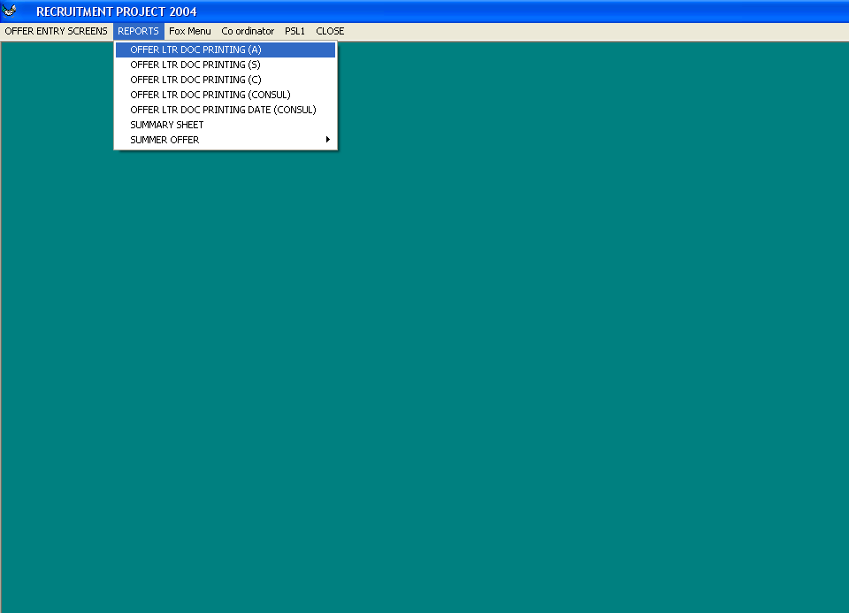

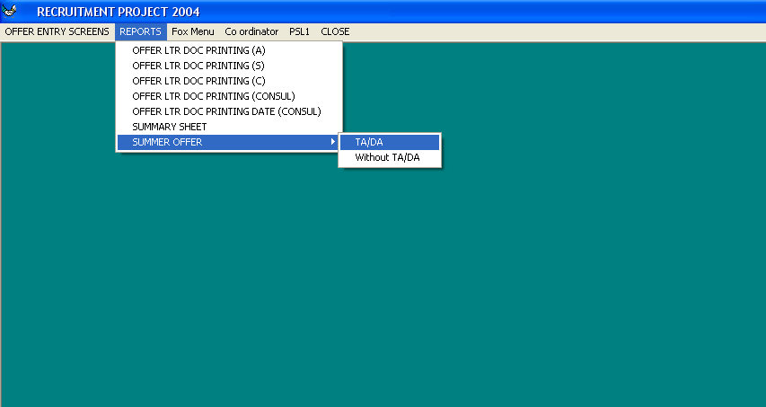

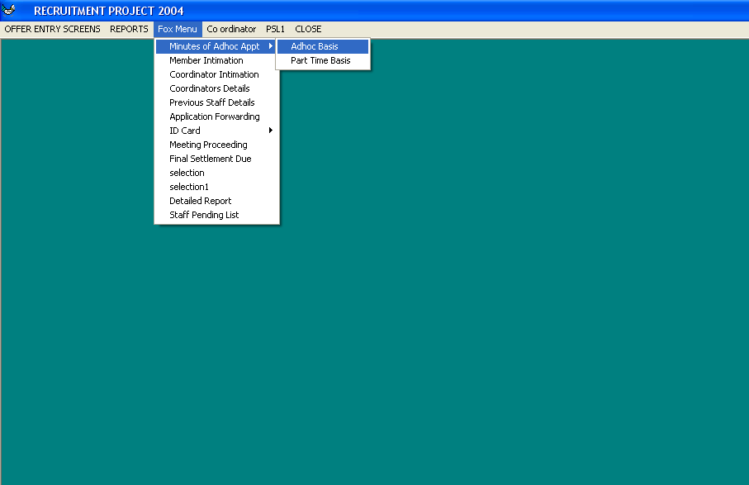

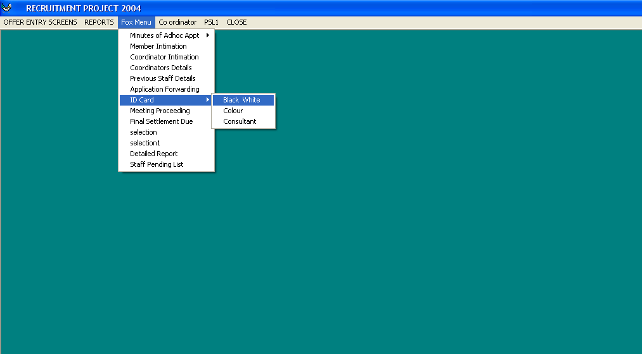

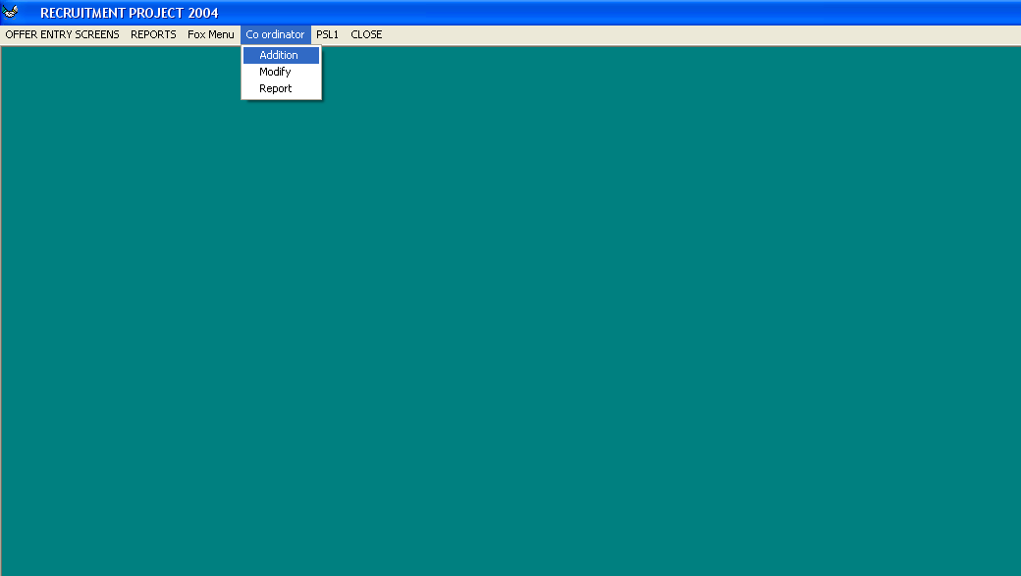

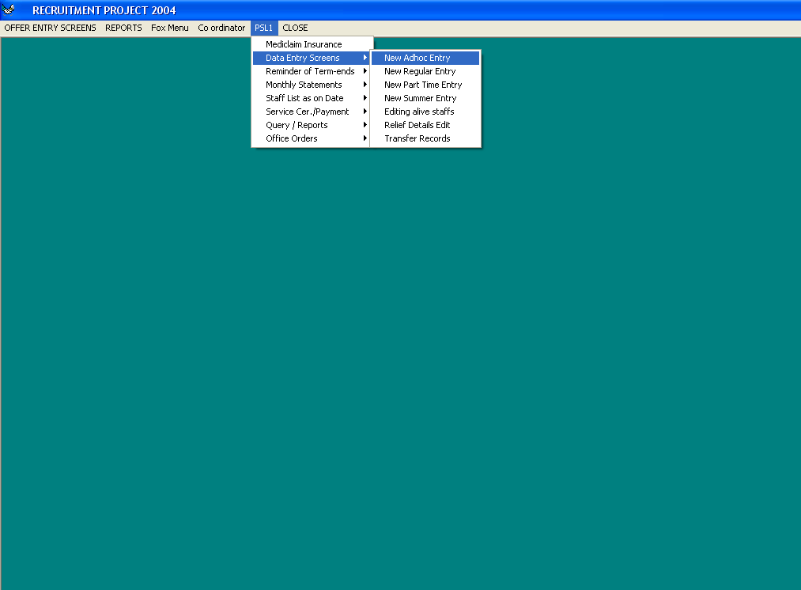

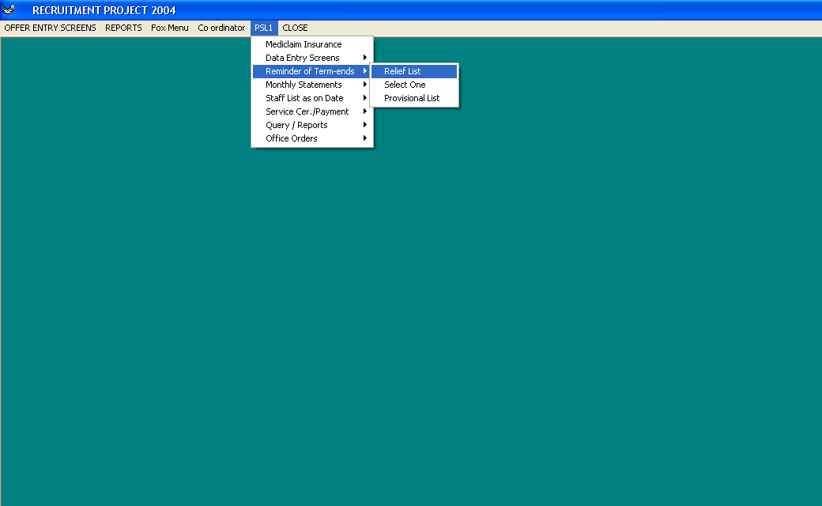

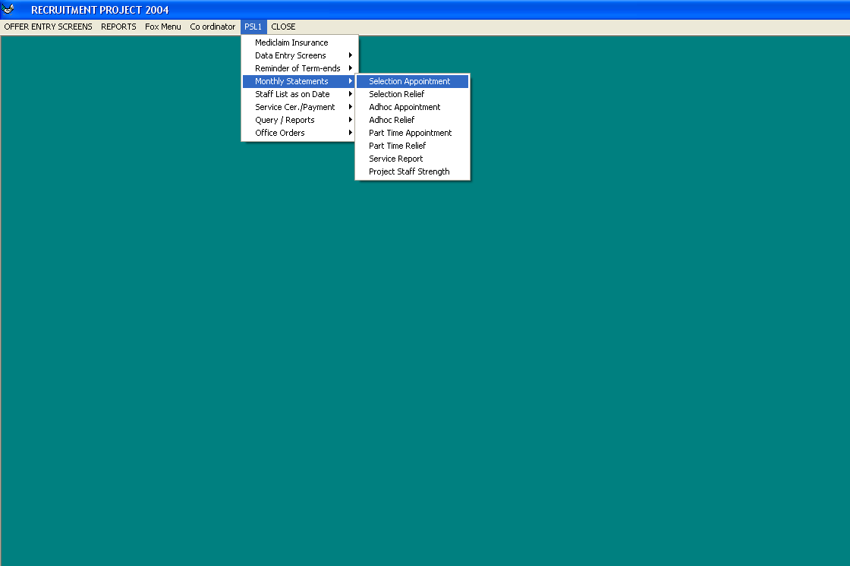

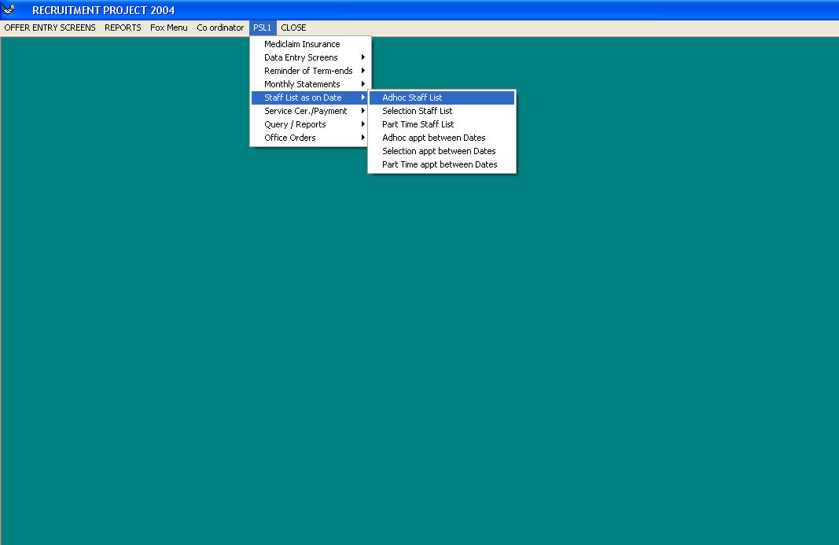

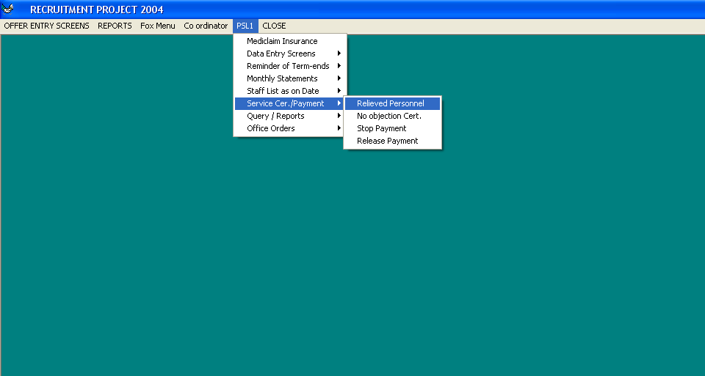

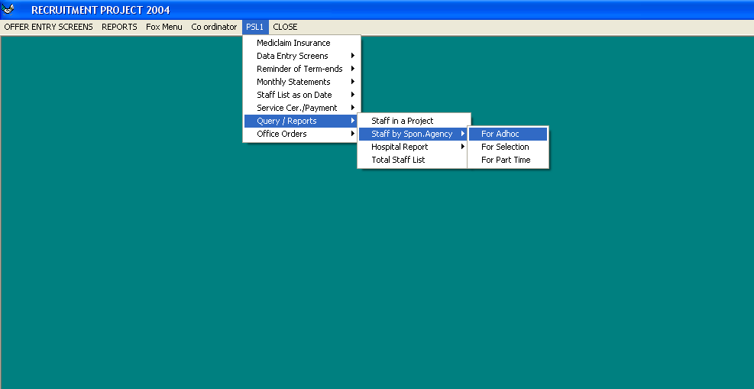

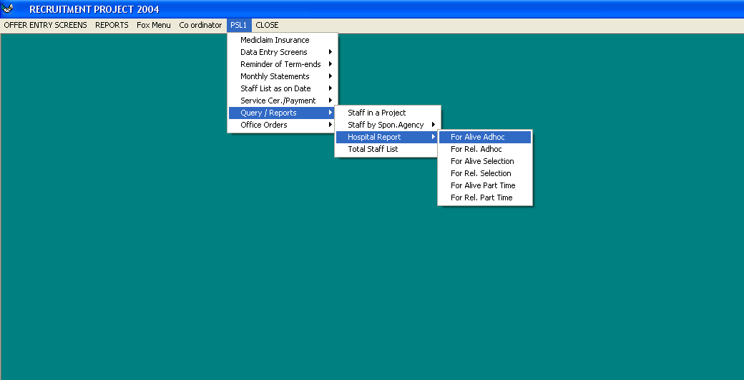

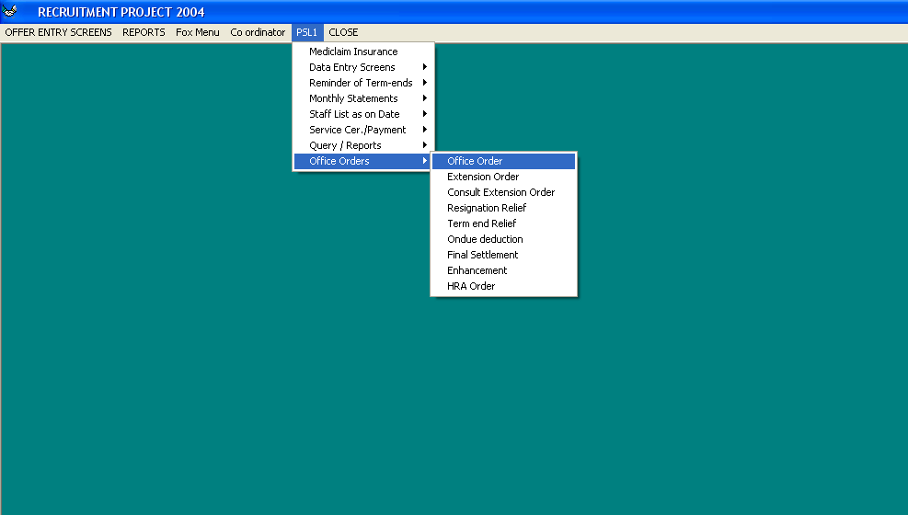

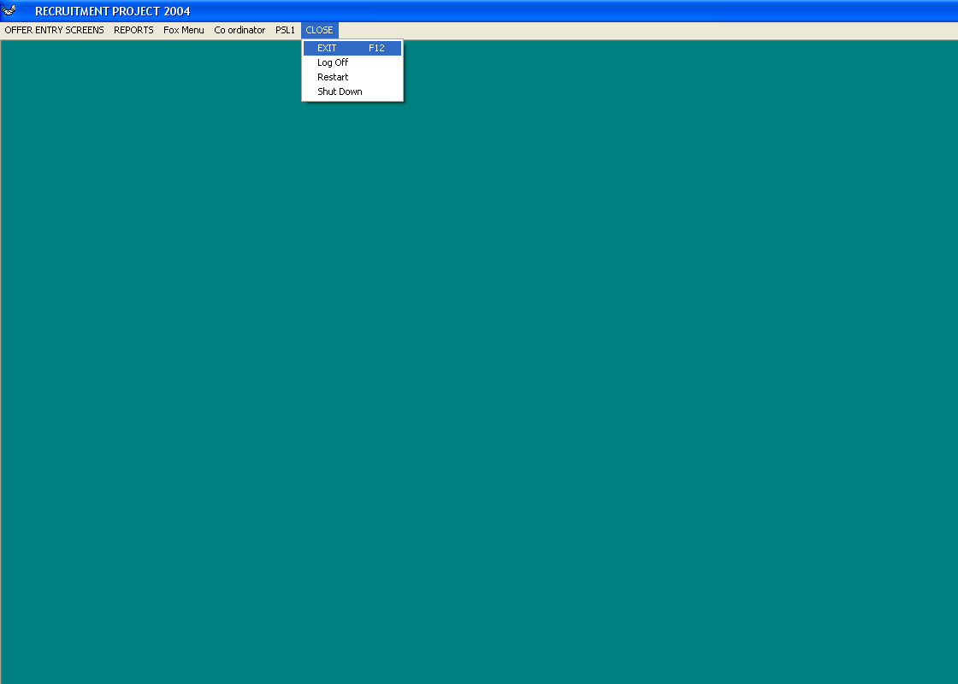

Offer Entry Screens

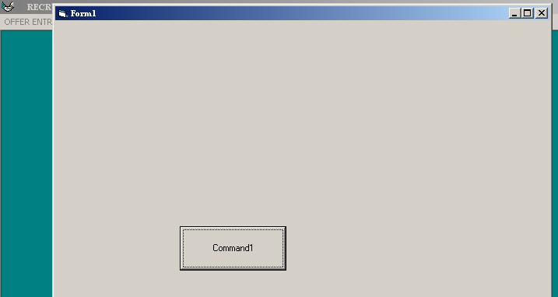
Figure 1: Offer entry screen – Form1

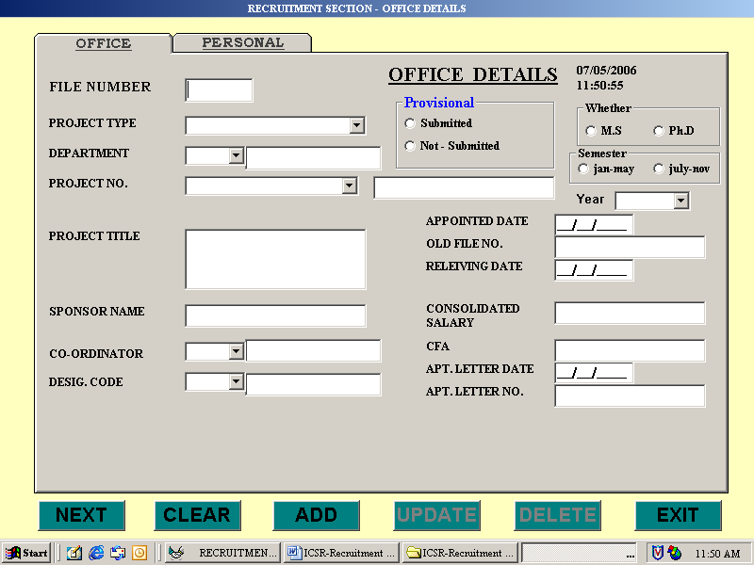
Figure 2: Offer entry screen – New Adhoc

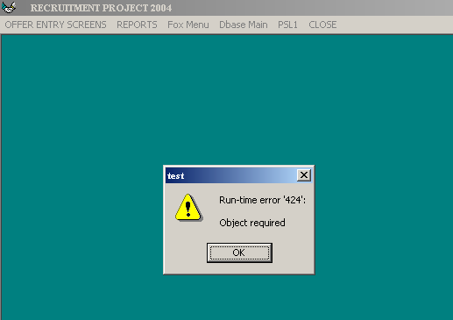
Figure 3: Offer entry screen – New selection

Offer entry screen – New part time (Not able to open the screen)

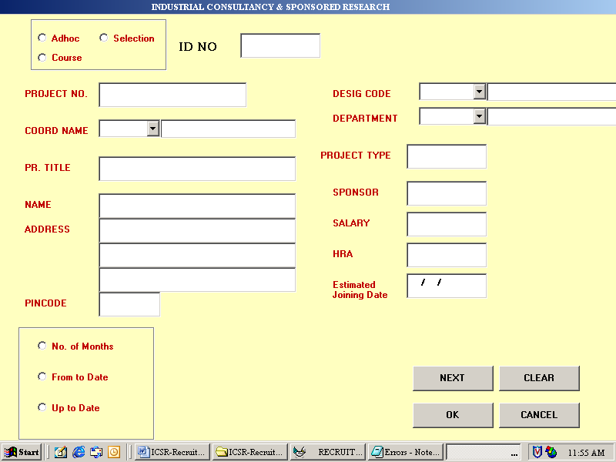
Figure 4: Offer entry screen – Offer letter entry

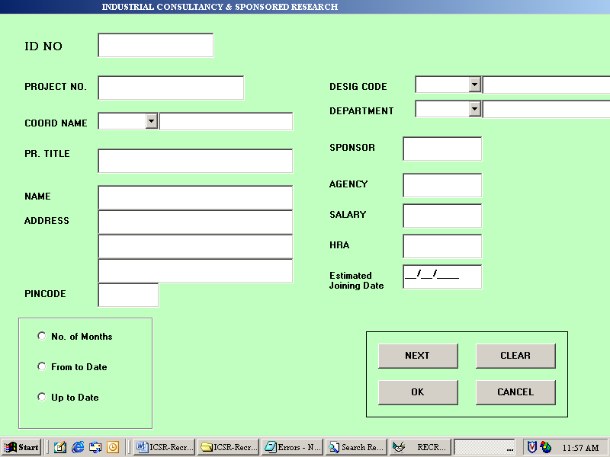
Figure 5: Offer entry screen – Offer letter modification

Offer entry screen – Offer letter modification (same time run time error 94 is also coming)

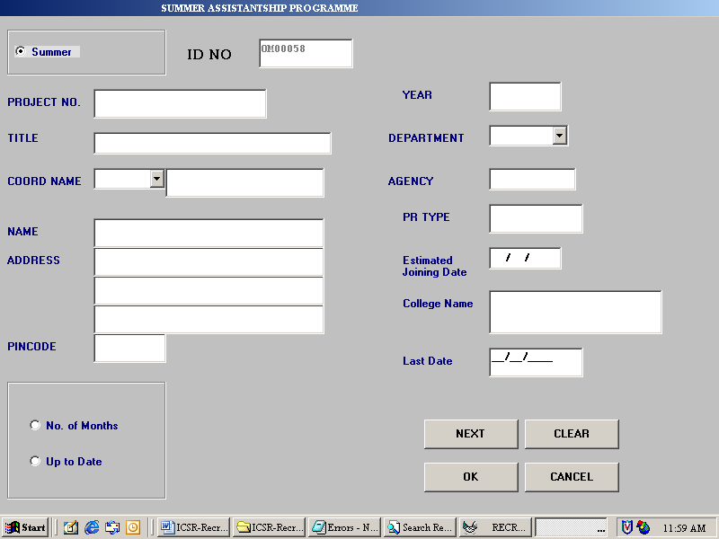
Figure 6: Offer entry screen – Summer Assistance

Reports

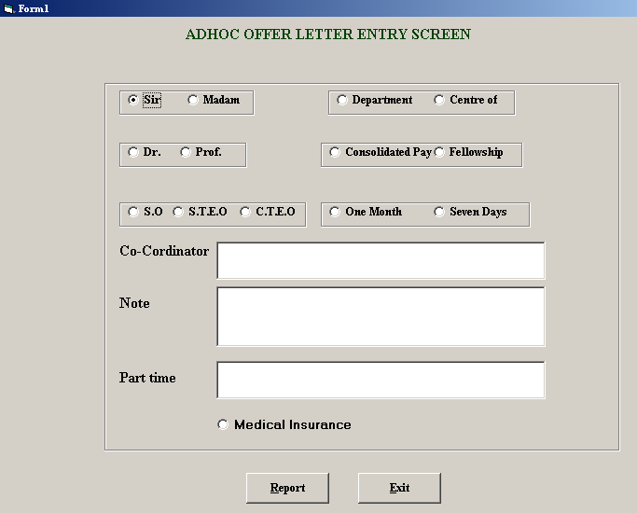
Figure 7: Reports - Offer LTR Doc Printing (A)

Offer LTR Doc Printing (A) (Report not able to generate because ID no. is not there)

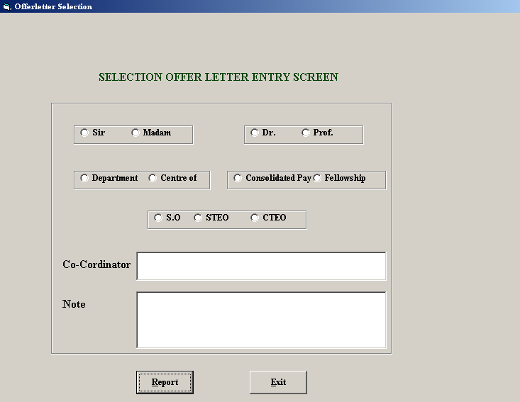
Figure 8: Reports - Offer LTR Doc Printing (S)

Offer LTR Doc Printing (S) (Report not able to generate because ID no. is not there)

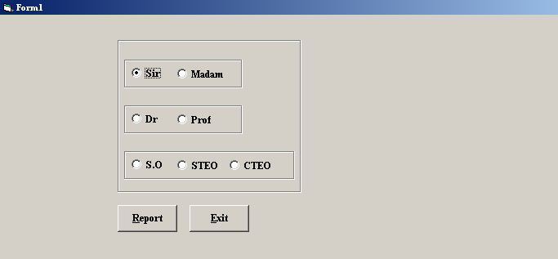
Figure 9: Reports - Offer LTR Doc Printing (C)
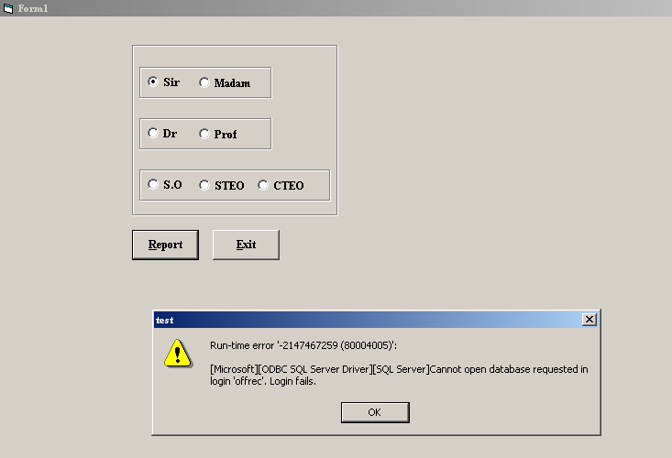
Figure 10: Reports - Offer LTR Doc Printing (C) ( Not able to generate report)

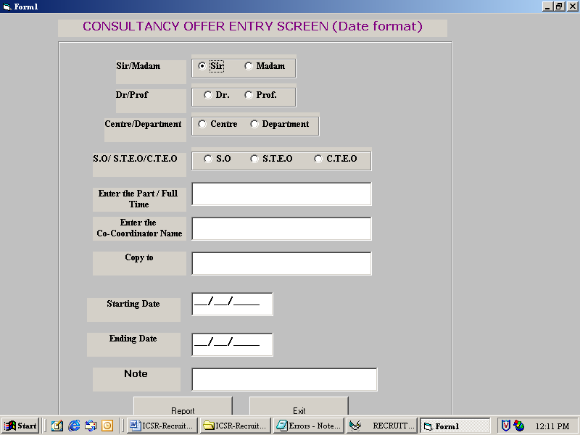
Figure 11: Offer LTR Doc Printing date(Consul)

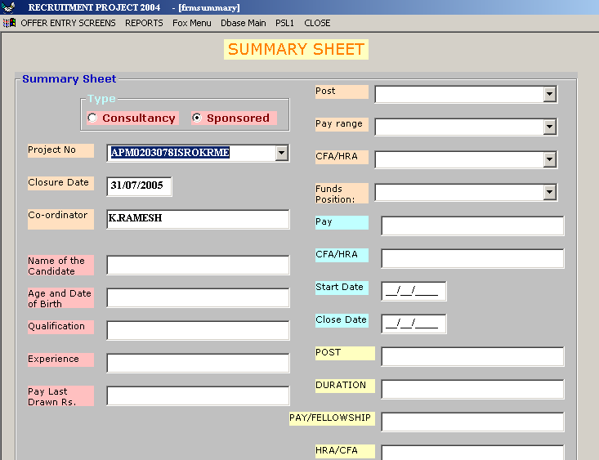
Figure 12: Reports – Summary Sheet

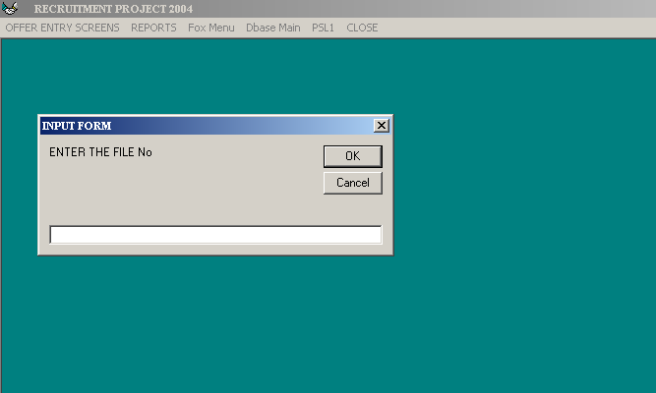
Figure 13: Reports – Summary Offer TA/DA
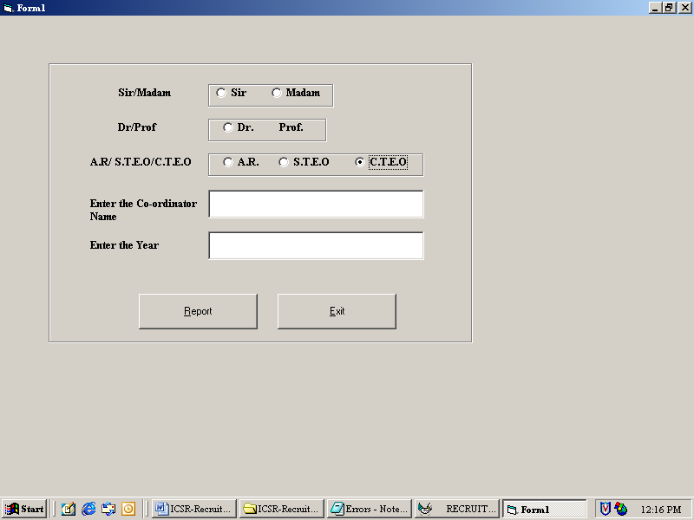
Figure 14: Reports – Summary Offer TA/DA (ID no. is not there, after entering the some number this screen is coming)

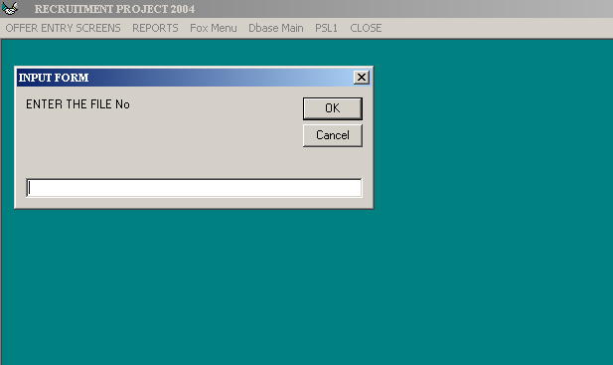
Figure 15: Reports – Summary Offer Without TA/DA
Reports – Summary Offer Without TA/DA (we don’t know the file no.)

FOX Menu

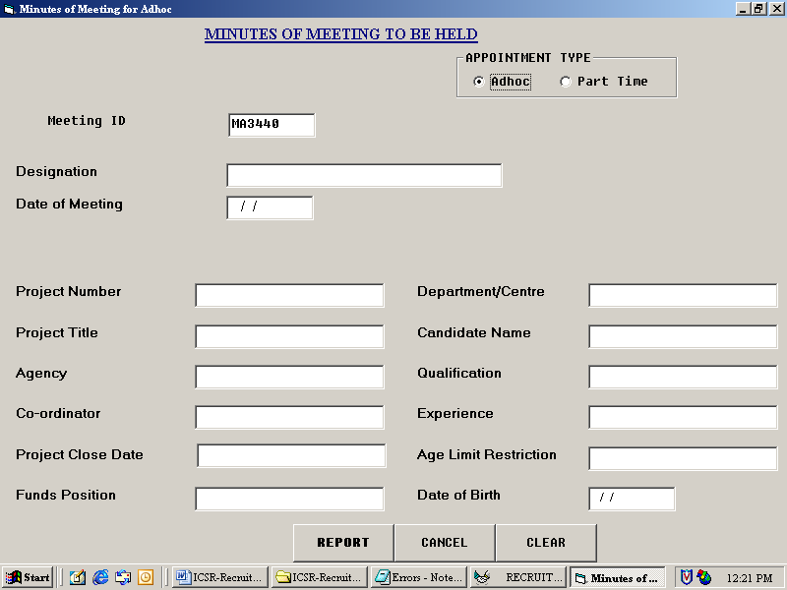
Figure 16: FOX Menu – Minutes of Adhoc Appt – Adhoc Basis

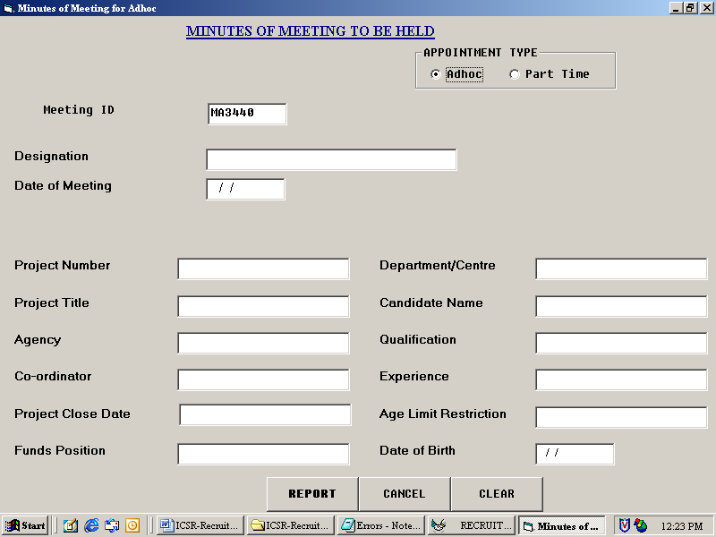
Figure 17: FOX Menu - Minutes of Adhoc Appt – Part time basis

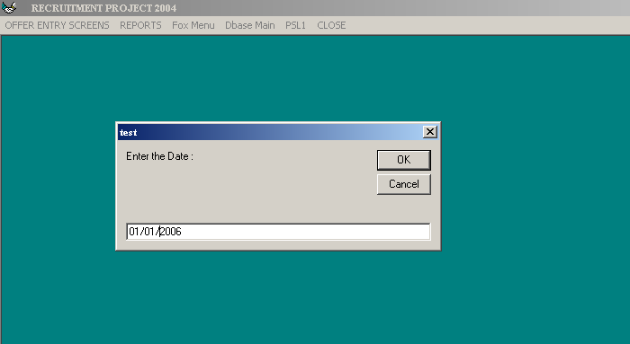
Figure 18: FOX Menu – Member Intimation (Date)
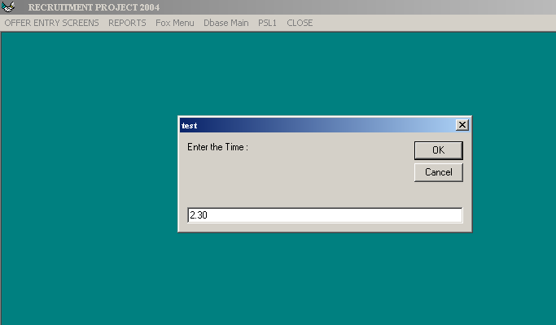
Figure 19: FOX Menu – Member Intimation (Time)

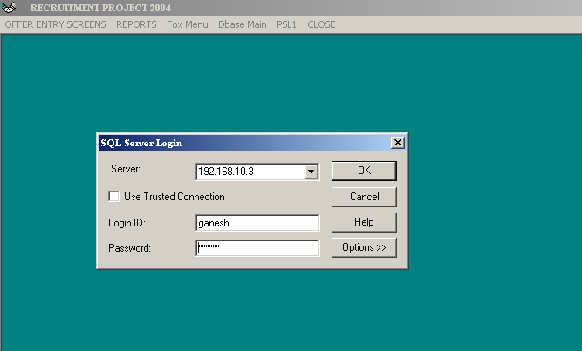
Figure 20: FOX Menu – Member Intimation (Server Login)
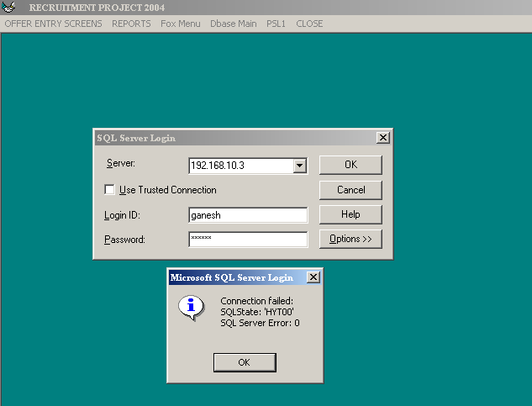
Figure 21: FOX Menu – Member Intimation (Server Login) - Error screen

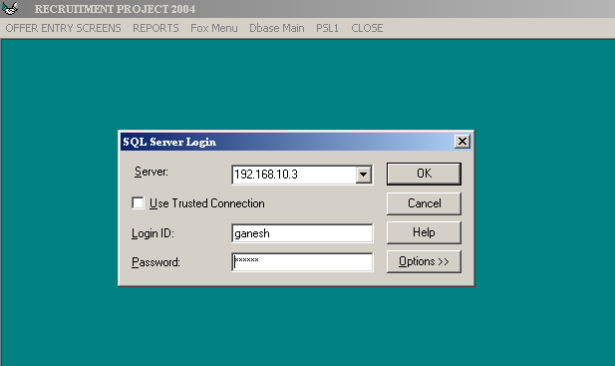
Figure 22: FOX Menu – Co-ordinator Intimation
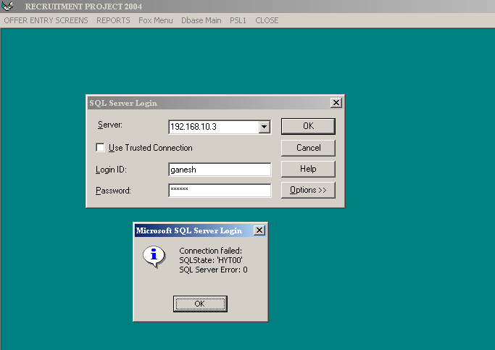
Figure 23: : FOX Menu – Co-ordinator Intimation (SQL server error)

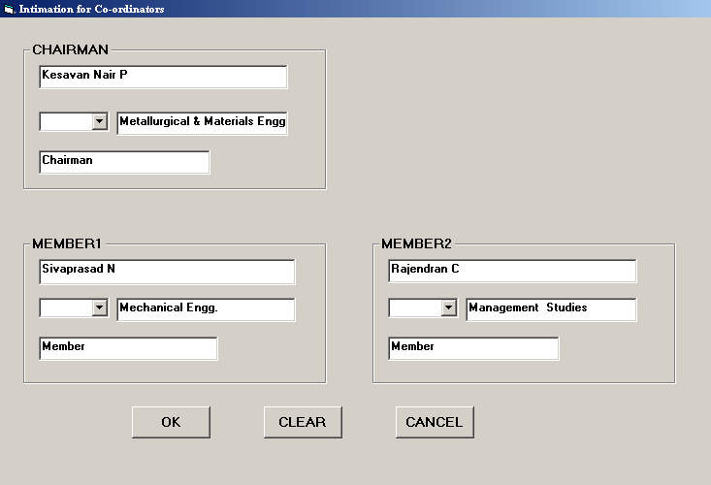
Figure 24: FOX Menu – Co-ordinators Details

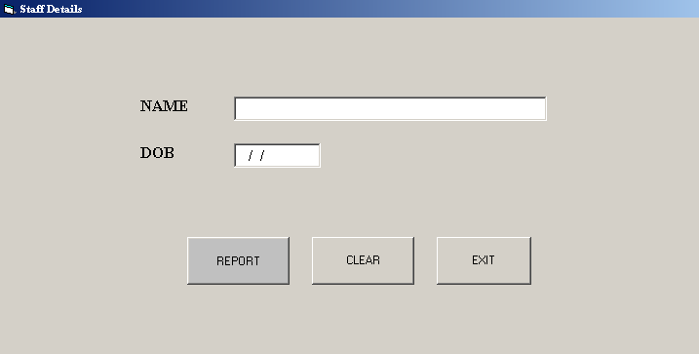
Figure 25:Fox Menu – Previous Staff Details

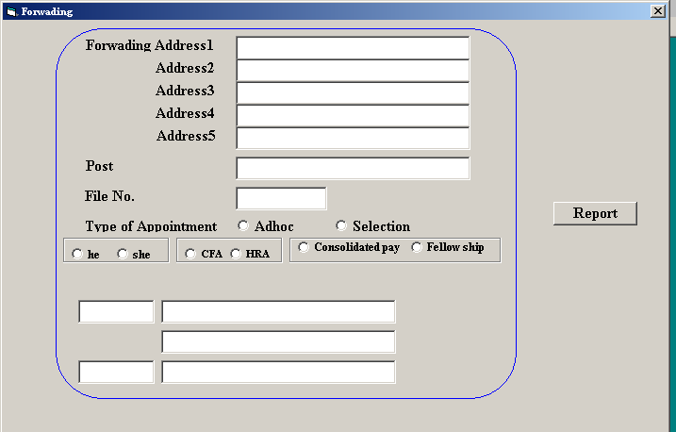
Figure 26: Fox Menu – Application Forwarding

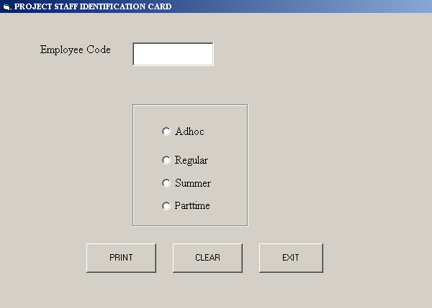
Figure 27: Fox Menu – ID Card – Black White

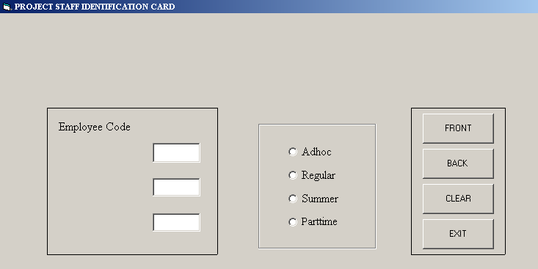
Figure 28: Fox Menu – ID Card – Colour

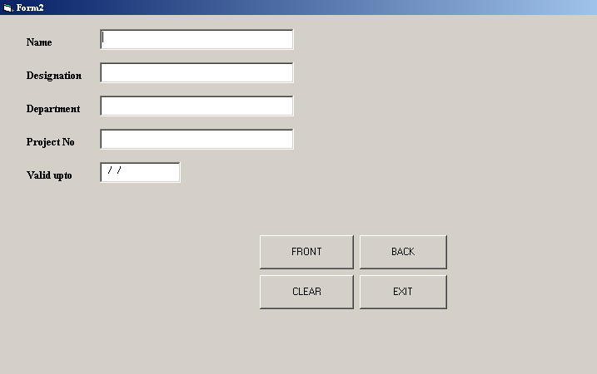
Figure 29: Fox Menu – ID Card – Consultant

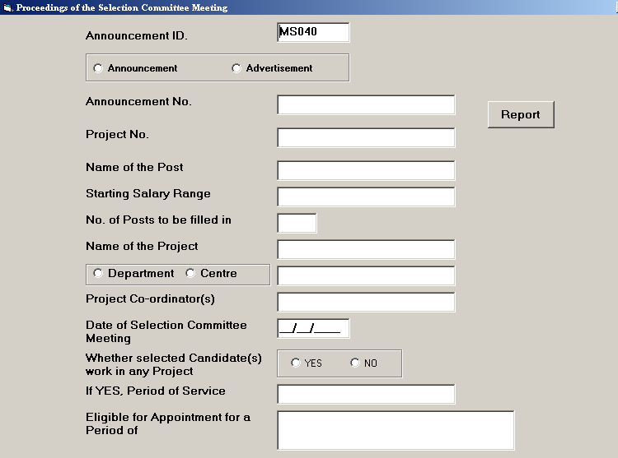
Figure 30: Fox Menu – Meeting Proceeding

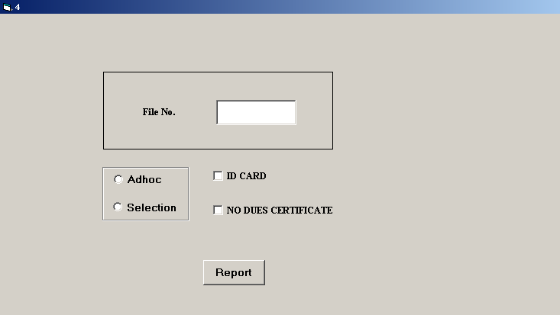
Figure 31: Fox Menu – Final Settlement Due

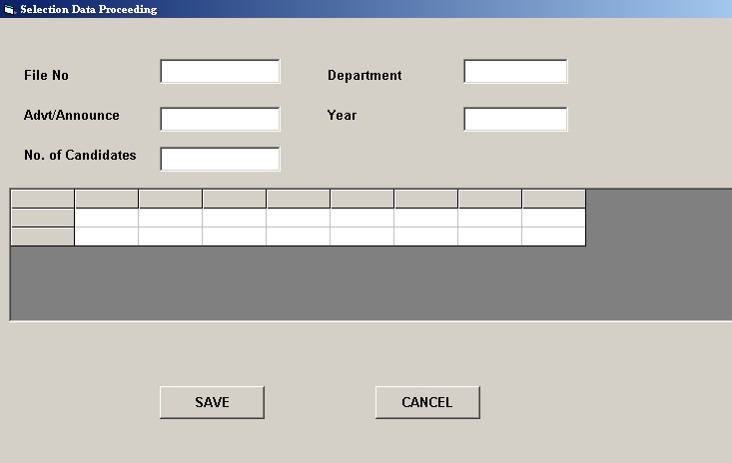
Figure 32: Fox Menu – Selection

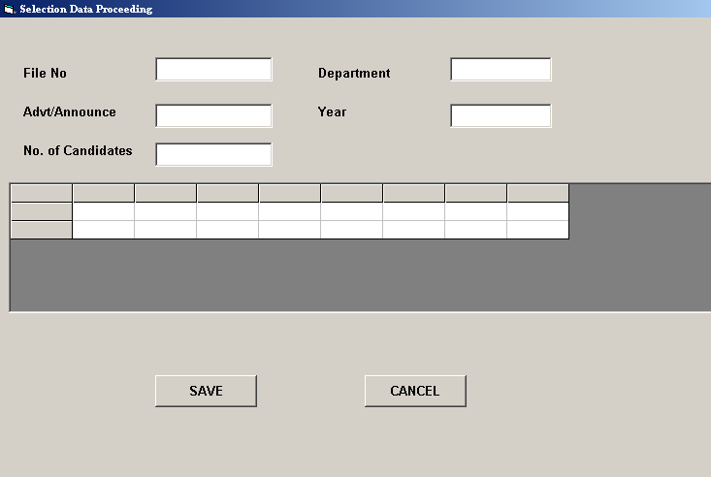
Figure 33: Fox Menu – Selection1

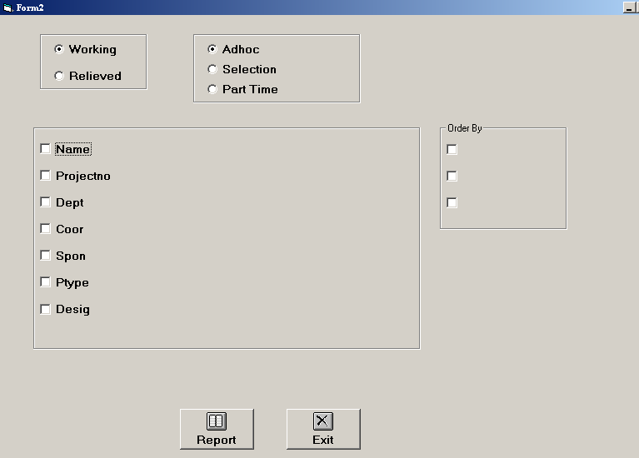
Figure 34: Fox Menu – Detailed Report

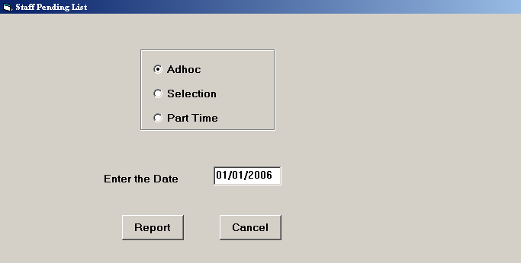
Figure 35: Fox Menu – Staff Pending list

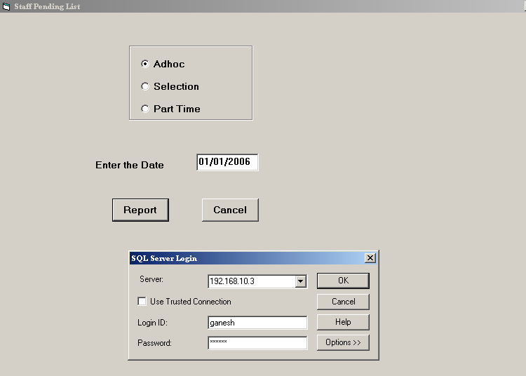
Figure 36: Fox Menu – Staff Pending list ( Connecting server)

Not able to connect server

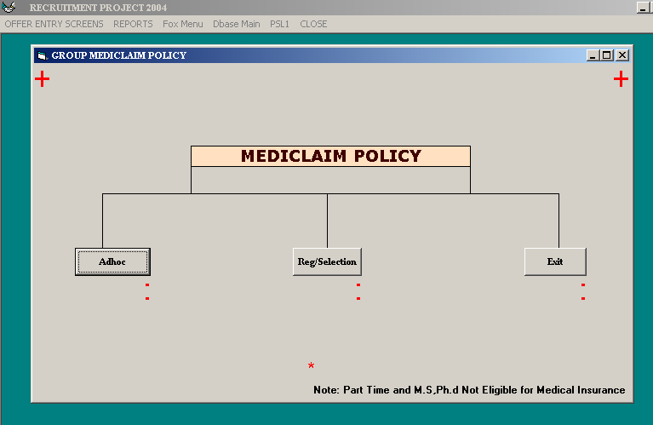
Figure 37: Fax menu – Group Mediclaim policy (Adhoc)

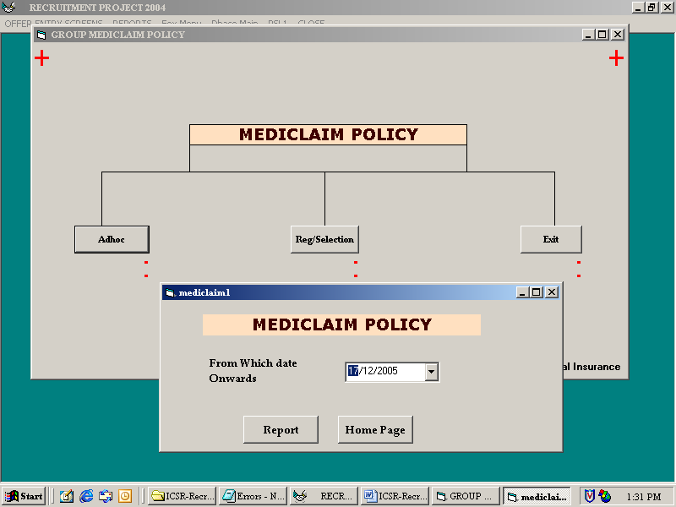
Figure 38: Fax menu – Group Mediclaim policy1

Fax menu – Group Mediclaim policy (Generated Report)

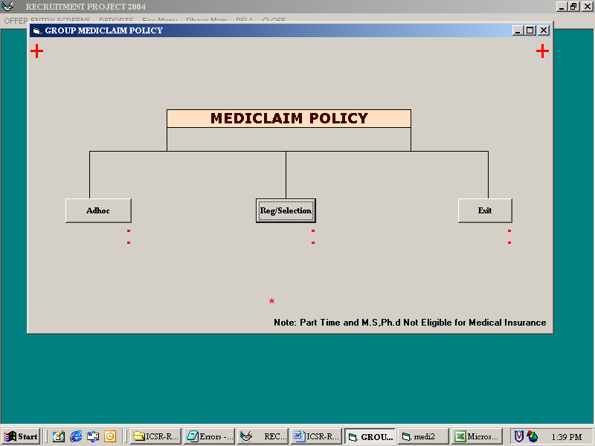
Figure 39: Fax menu – Group Mediclaim policy (Reg/Selection)

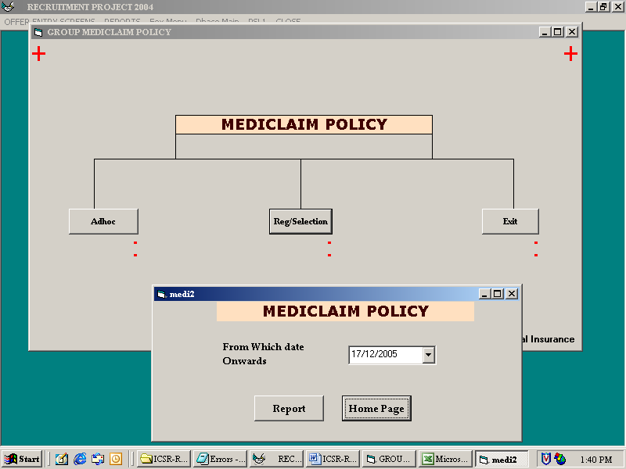
Figure 40: Fax menu – Group Mediclaim policy1 (Reg/Selection)

Fax menu – Group Mediclaim policy (Reg/Selection) – Generated Report

Fax menu – Group Mediclaim policy – Exit

Dbase Main

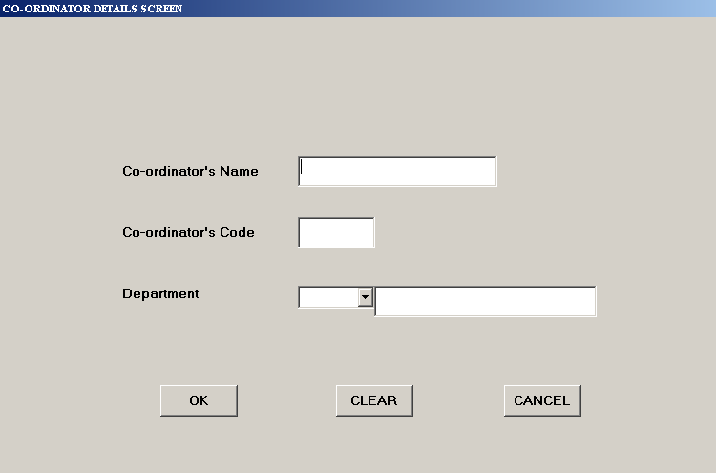
Figure 41: Dbase Main - Addition

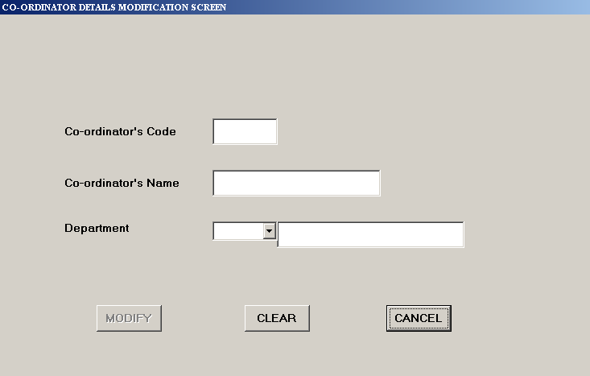
Figure 42: Dbase Main - Modify

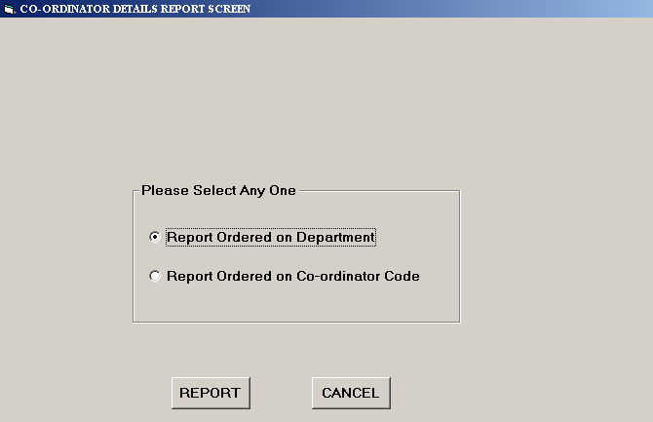
Figure 43: Dbase Main – Report

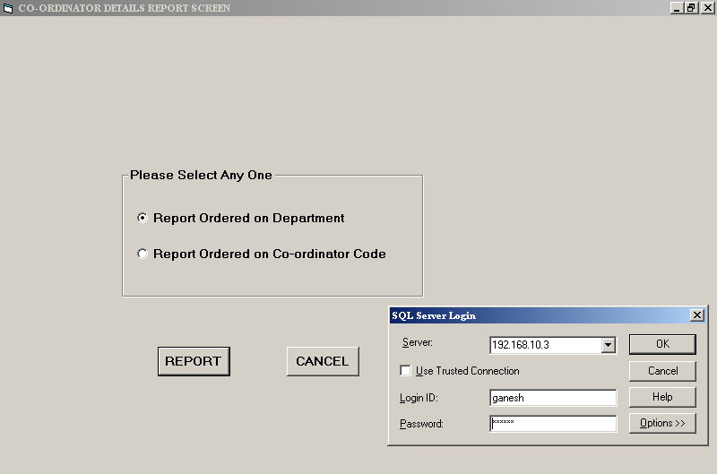
Figure 44: Dbase Main – Report (Server Login Screen)
Not able to login server screen

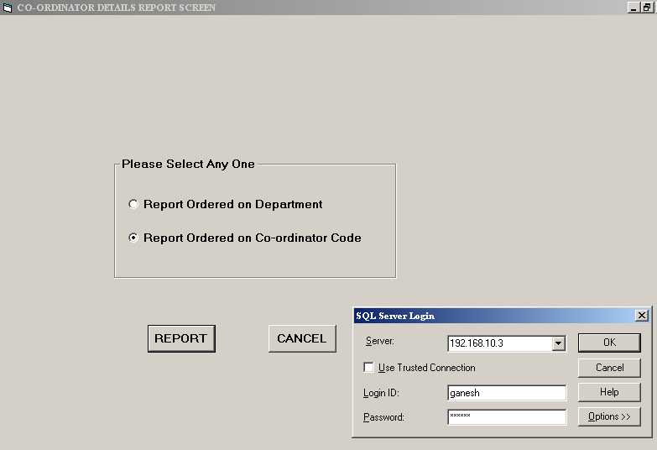
Figure 45: Dbase Main – Report (Server Login Screen)

PSL1

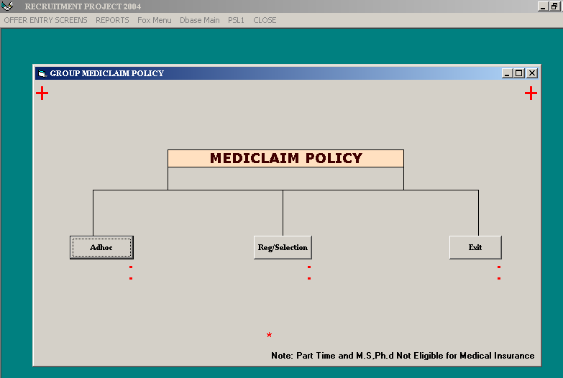
Figure 46: PSL1-Mediclaim insurance (Adhoc)

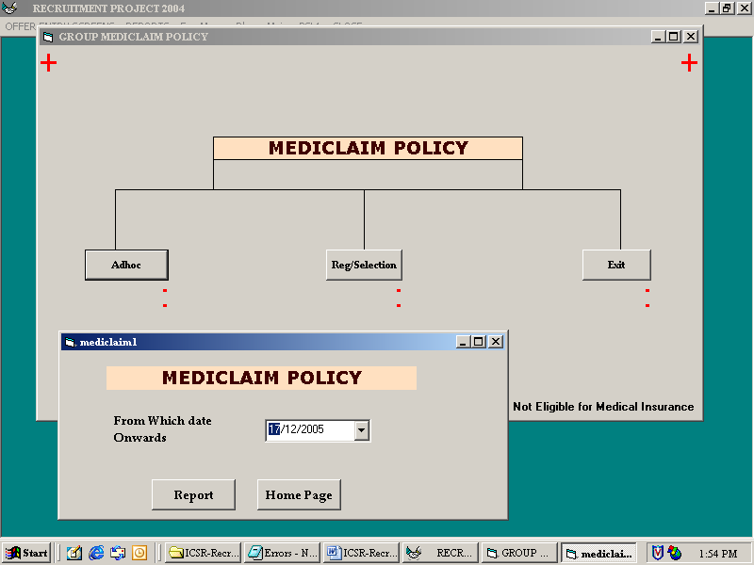
Figure 47: PSL1-Mediclaim insurance1 (Adhoc)

PSL1-Mediclaim insurance (Adhoc) – Generated Report

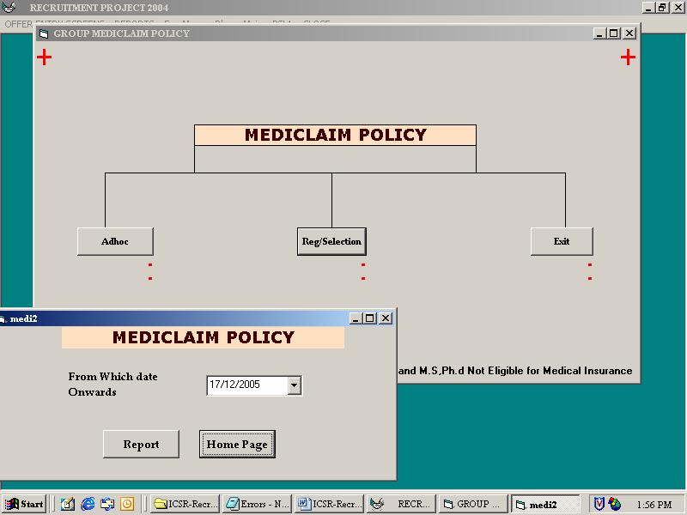
Figure 48: PSL1-Mediclaim insurance – (Reg.Selection )

PSL1-Mediclaim insurance1 – (Reg.selection) – Generated Report

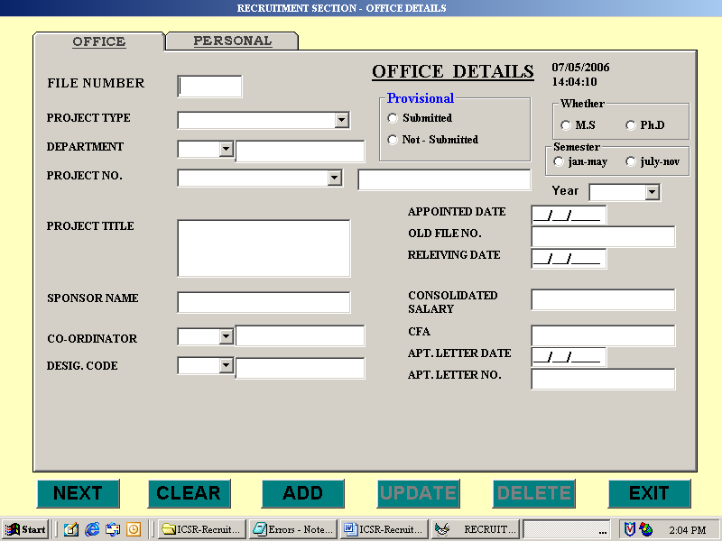

Figure 49: PSL1 – Data Entry Screens – New Adhoc Entry

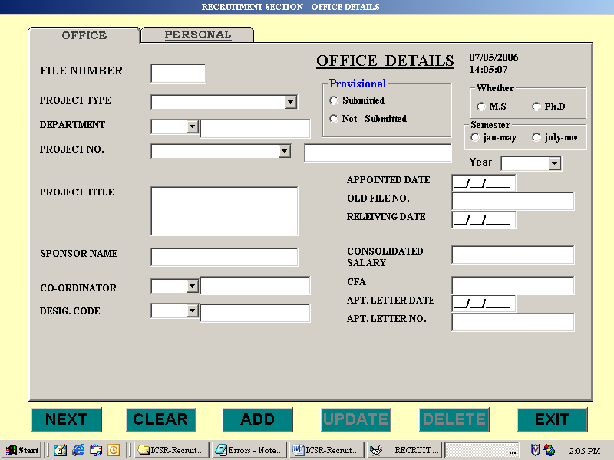
Figure 50: PSL1 – Data Entry Screens – New Regular Entry

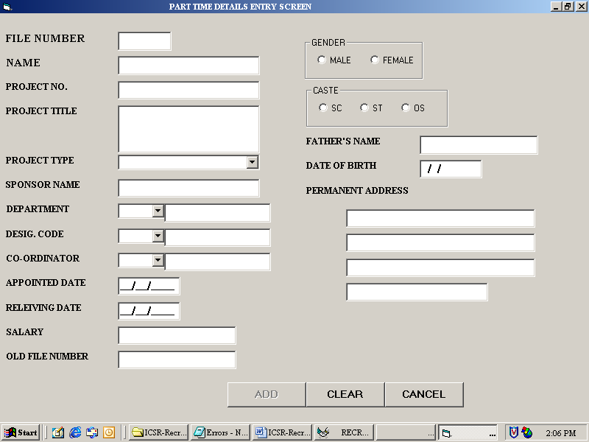
Figure 51: PSL1 – Data Entry Screens – New part time entry

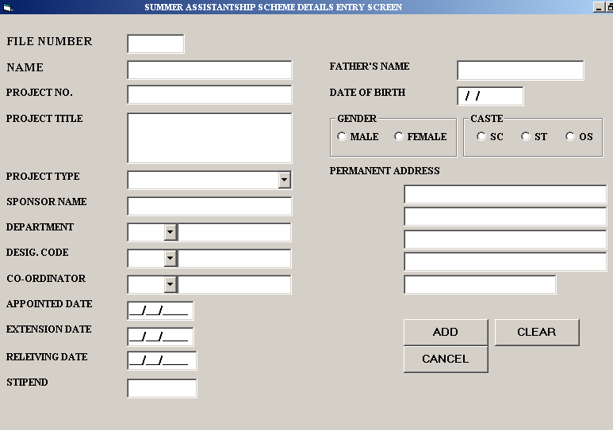
Figure 52: PSL1 – Data Entry Screens – New summer entry
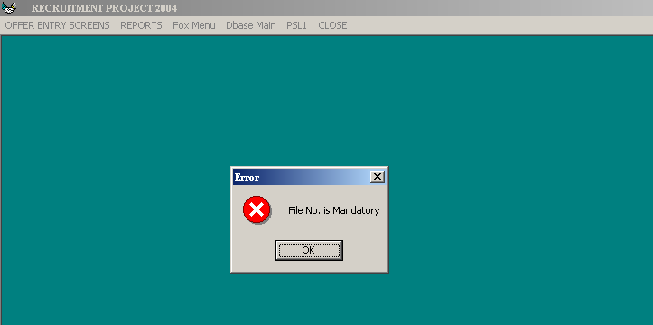
Figure 53: PSL1 – Data Entry Screens – New summer entry (error)

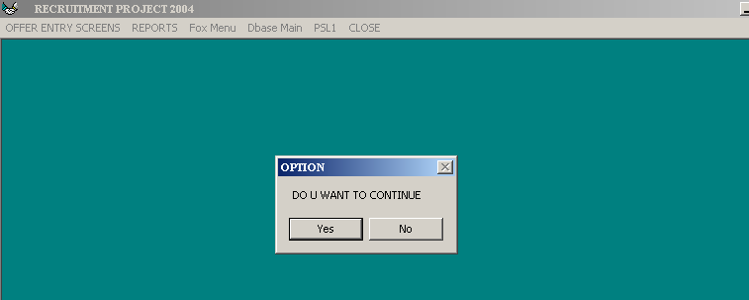
Figure 54: PSL1 – Data Entry Screens – New summer entry (message)

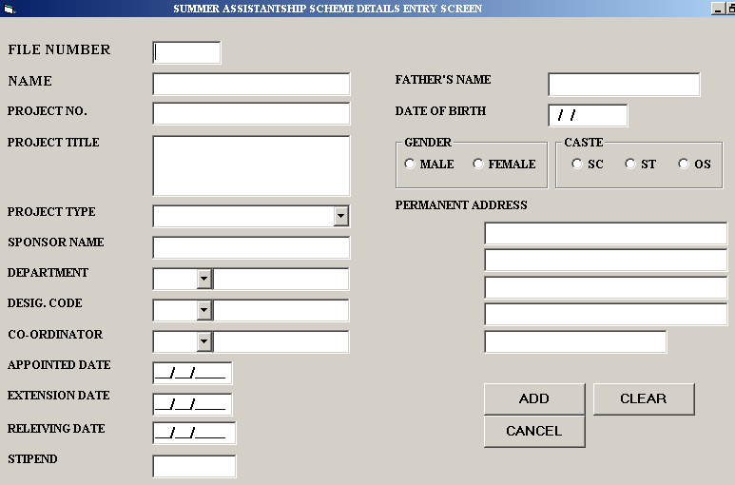
Figure 55: PSL1 – Data Entry Screens – New summer entry

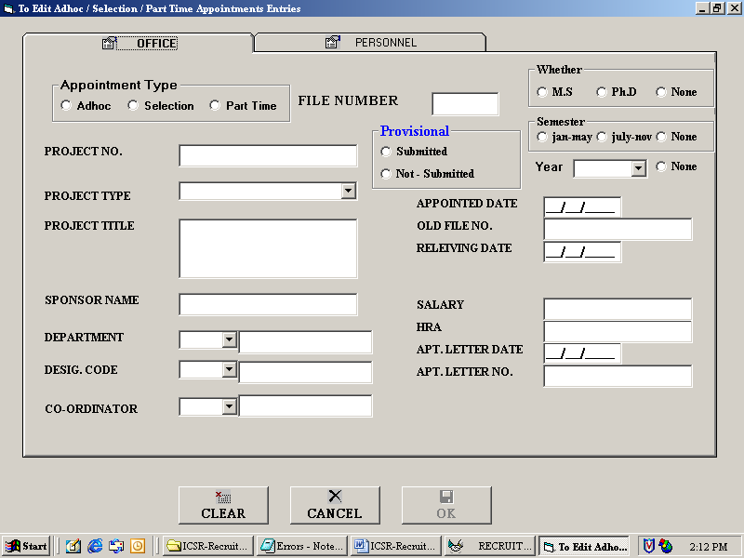
Figure 56: PSL1 – Data Entry Screens – Editing alive staffs

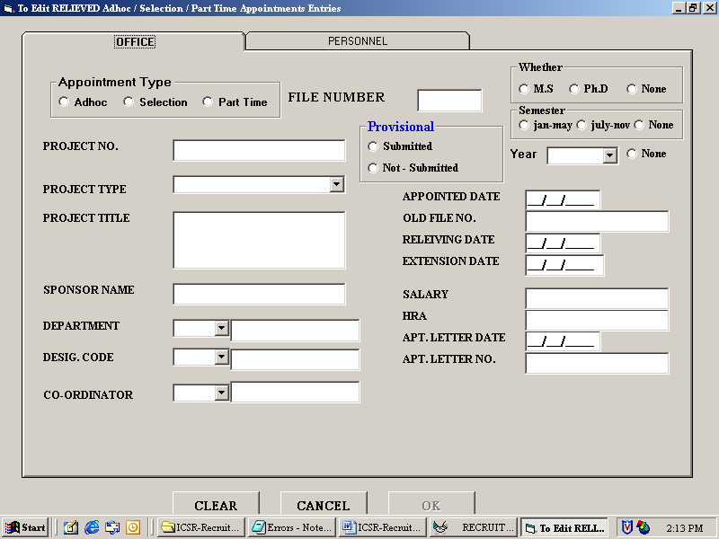
Figure 57: PSL1 – Data Entry Screens – Relief details Edit

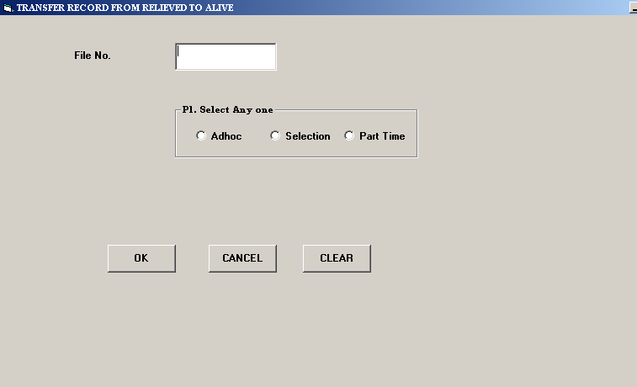
Figure 58: PSL1 – Data Entry Screens – Transfer Records

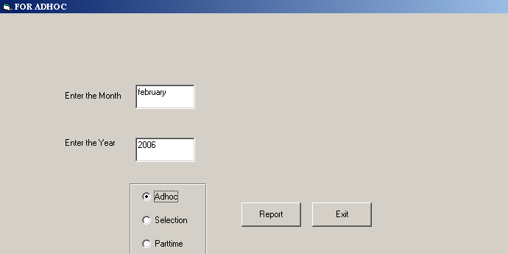
Figure 59: PSL1-Reminder of Term-ends – Relief List

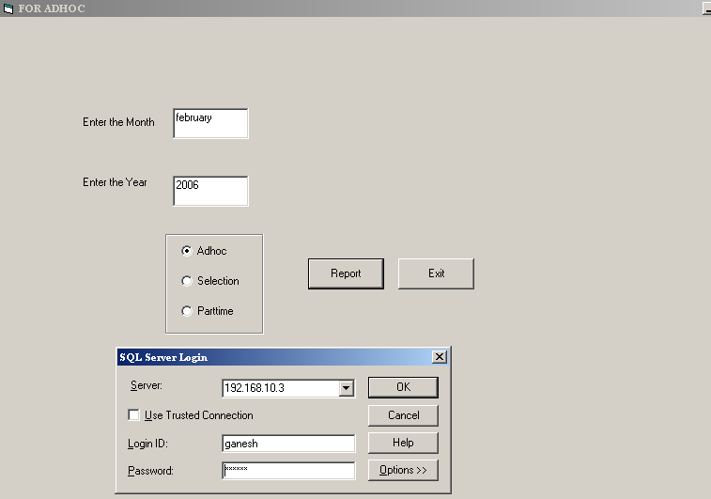
Figure 60: PSL1-Reminder of Term-ends – Relief List (Server Login Screen)

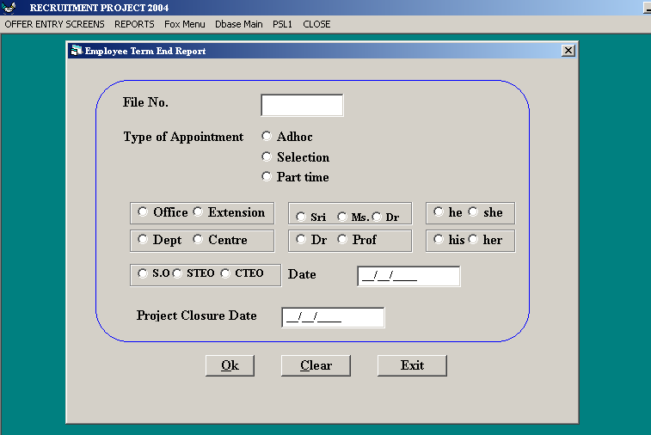
Figure 61: PSL1-Reminder of Term-ends – Select one

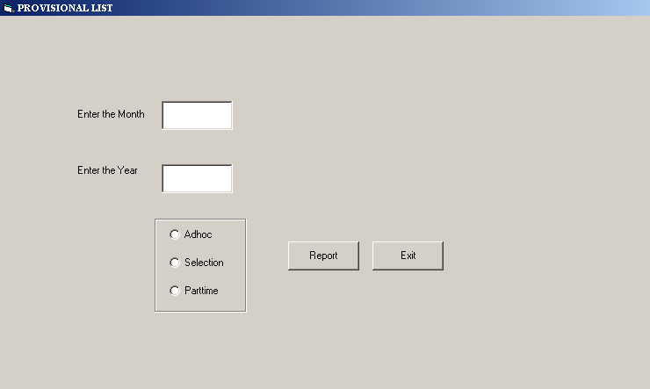
Figure 62: PSL1-Reminder of Term-ends – Provisional List

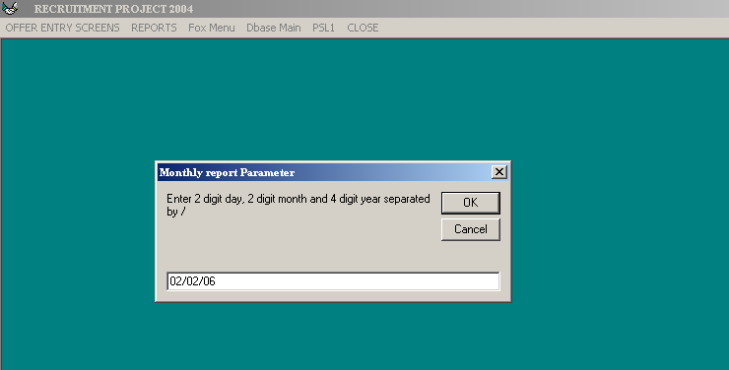
Figure 63: PSL1-Monthly Statements – Selection Appointment

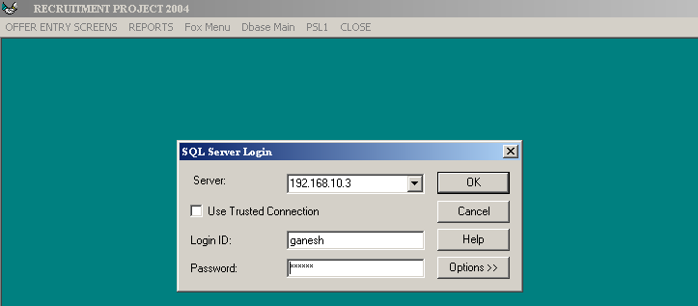
Figure 64: PSL1-Monthly Statements – Selection Appointment (Login Screen)

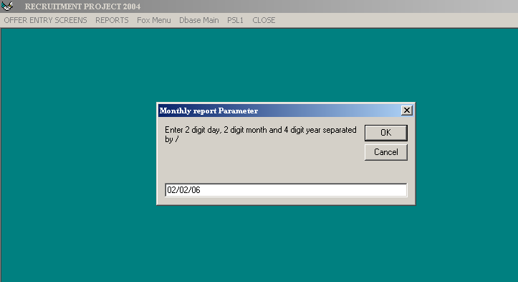
Figure 65: PSL1-Monthly Statements – Selection Relief

After entering the date ,Timed out error is coming

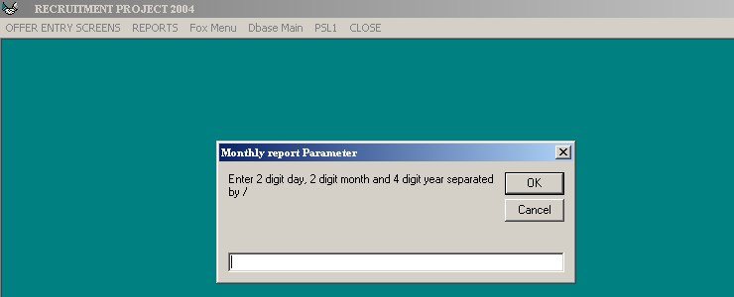
Figure 66: PSL1-Monthly Statements – Adhoc Appointment

After entering the date ,Timed out error is coming

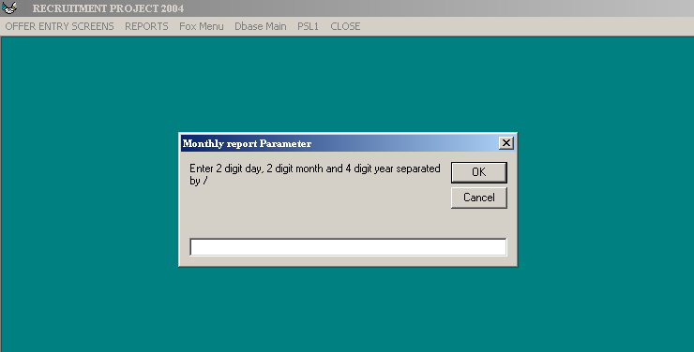
Figure 67: PSL1-Monthly Statements – Adhoc Relief

After entering the date ,Timed out error is coming

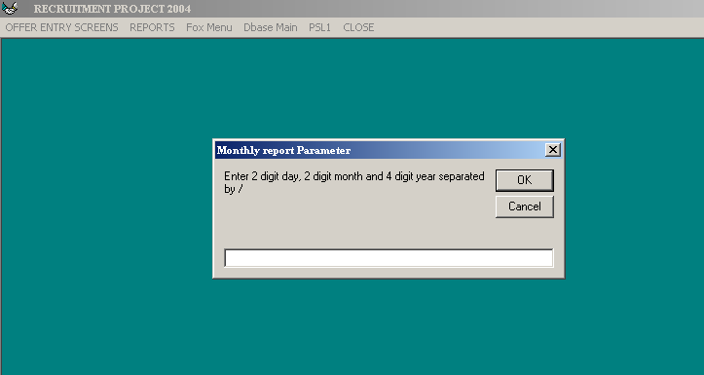
Figure 68: PSL1-Monthly Statements - Part time appointment

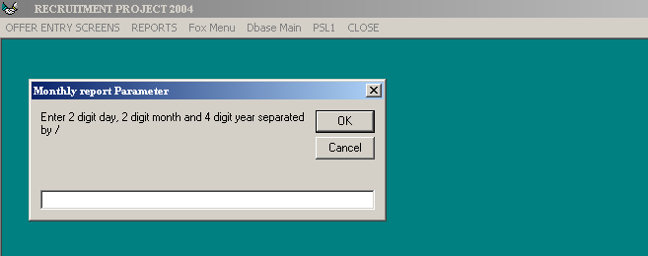
Figure 69: PSL1-Monthly Statements - Part time relief

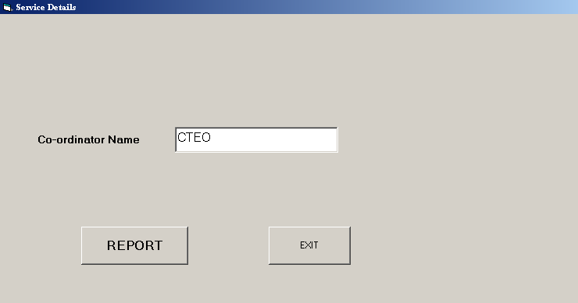
Figure 70: PSL1-Monthly Statements - Service report

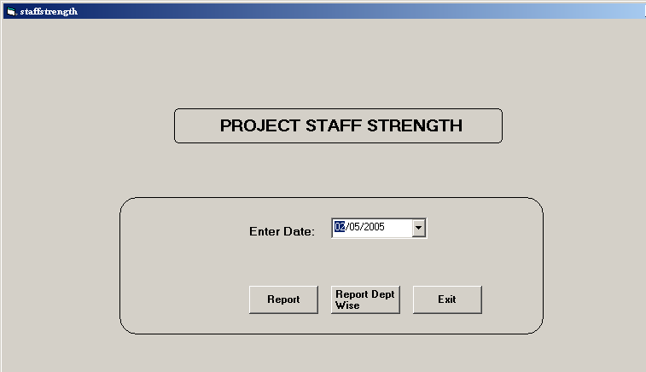
Figure 71: PSL1-Monthly Statements – project staff strength
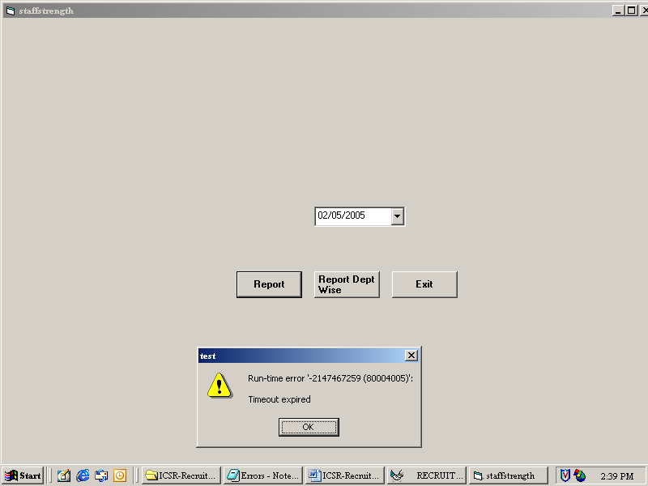
Figure 72: PSL1-Monthly Statements – project staff strength (error)

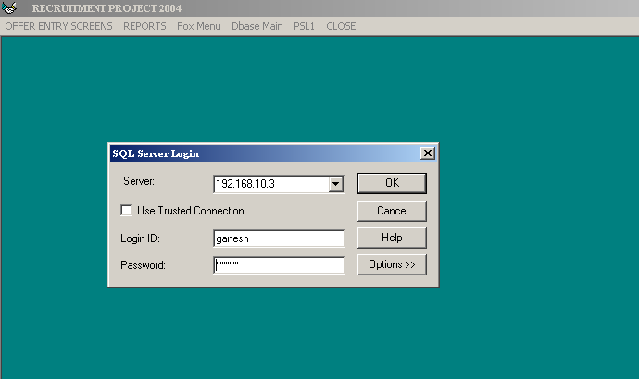
Figure 73: PSL1-Staff List as on Date – Adhoc Staff List (Server Login Screen)

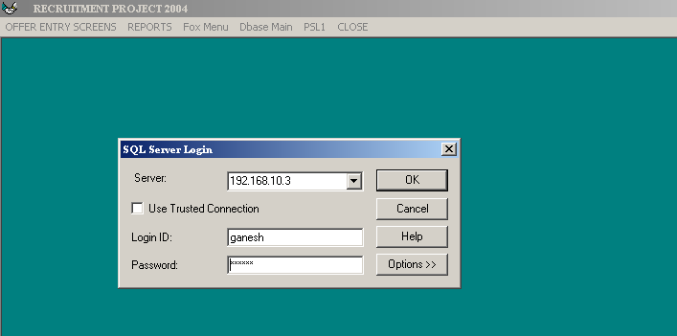
Figure 74: PSL1-Staff List as on Date – Selection staff list (Server Login Screen)

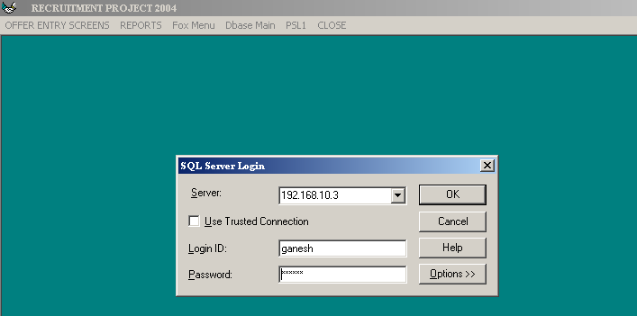
Figure 75: PSL1-Staff List as on Date –Part time staff list ( Login Screen)

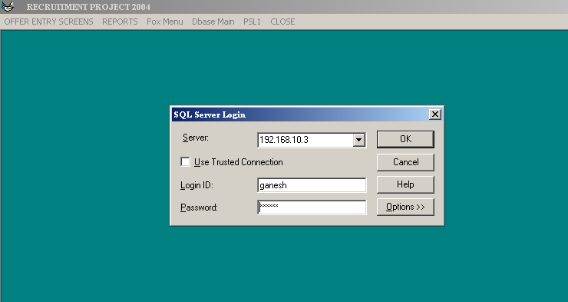
Figure 76: PSL1-Staff List as on Date – Adhoc appt between dates (Login Screen)

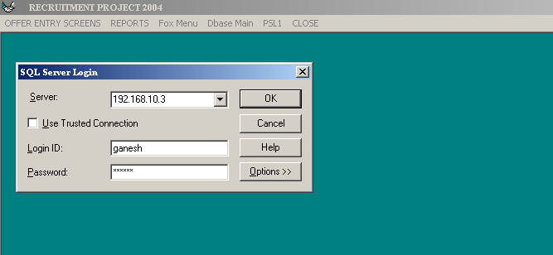
Figure 77: PSL1-Staff List as on Date – part time appt between dates (Login Screen)

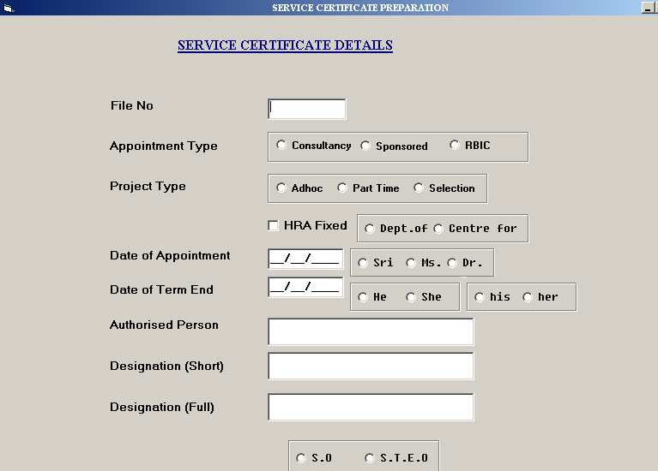
Figure 78: PSL1- Service Cer./Payment – Relieved personnel

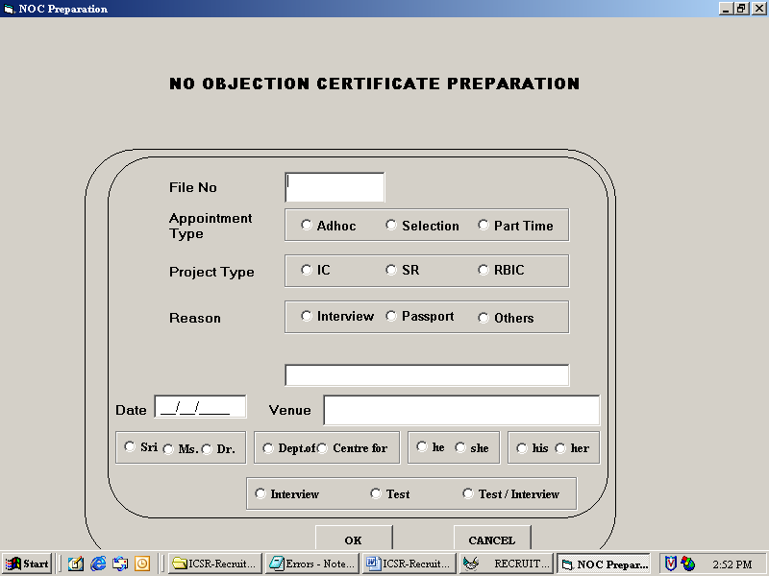
Figure 79: PSL1- Service Cer./Payment - No objection certificate

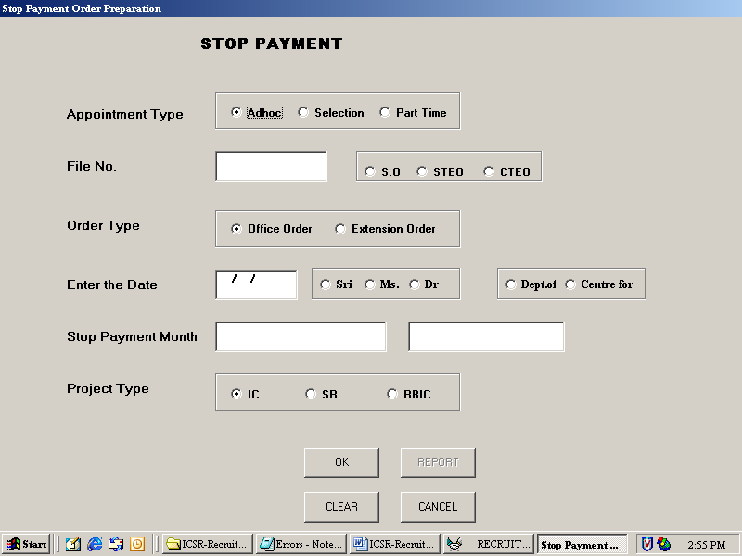
Figure 80: PSL1- Service Cer./Payment – Stop Payment

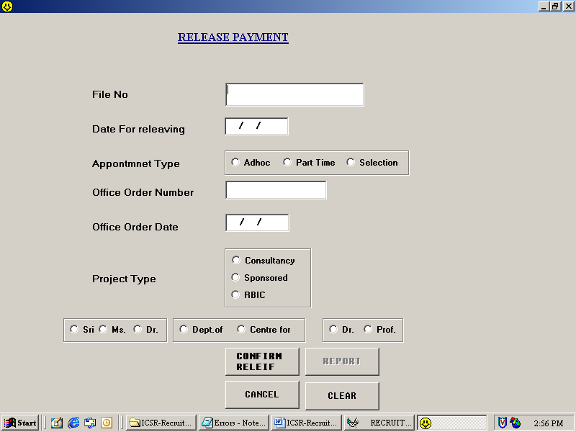
Figure 81: PSL1- Service Cer./Payment – Release Payment

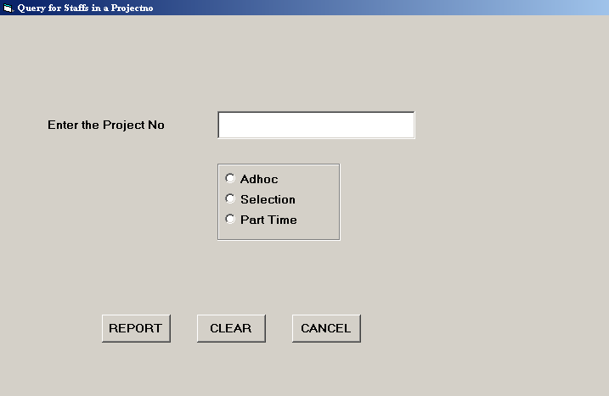
Figure 82: PSL1 - Query/Reports – Staff in a Project

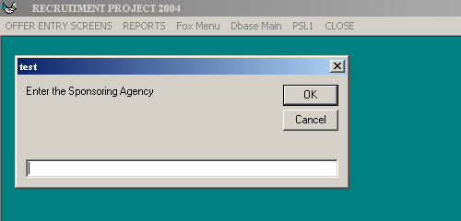
Figure 83: PSL1 - Query/Reports – Staff by Spon.Agency – For Adhoc

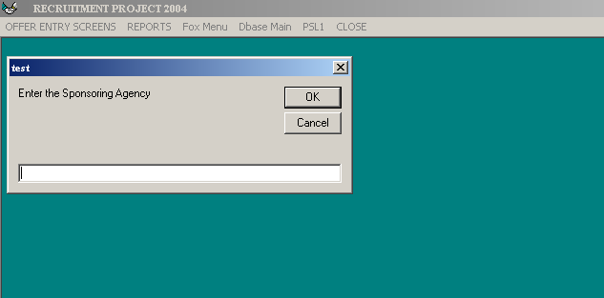
Figure 84: PSL1 - Query/Reports – Staff by Spon.Agency – For selection

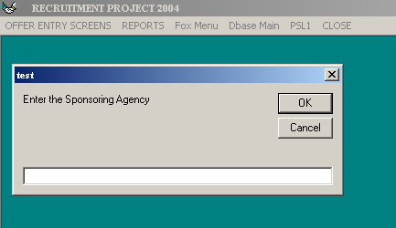
Figure 85: PSL1 - Query/Reports – Staff by Spon.Agency – For part time

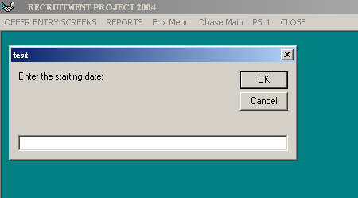
Figure 86: PSL1 - Query/Reports – Hospital Report – For Alive Adhoc

Enter the Server Login screen

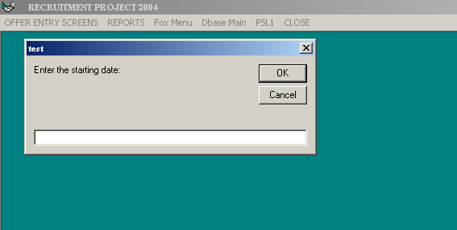
Figure 87: PSL1 - Query/Reports – Hospital Report – For rel.adhoc

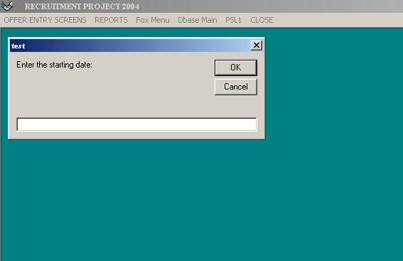
Figure 88: PSL1 - Query/Reports – Hospital Report – For Alive selection

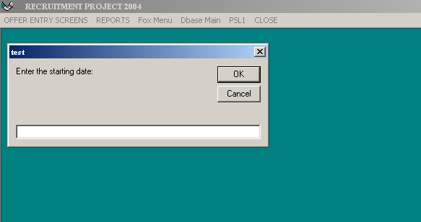
Figure 89: PSL1 - Query/Reports – Hospital Report – For Rel.selection

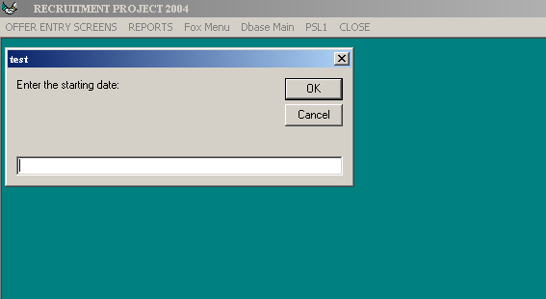
Figure 90: PSL1 - Query/Reports – Hospital Report – For alive part time

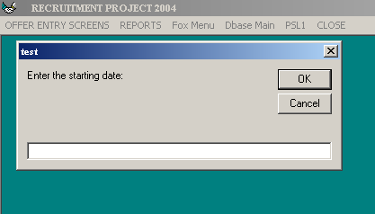
Figure 91: PSL1 - Query/Reports – Hospital Report – For rel. part time

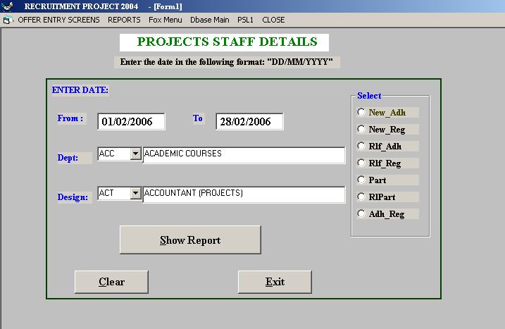
Figure 92: PSL1 - Query/Reports – Hospital Report – Total staff list

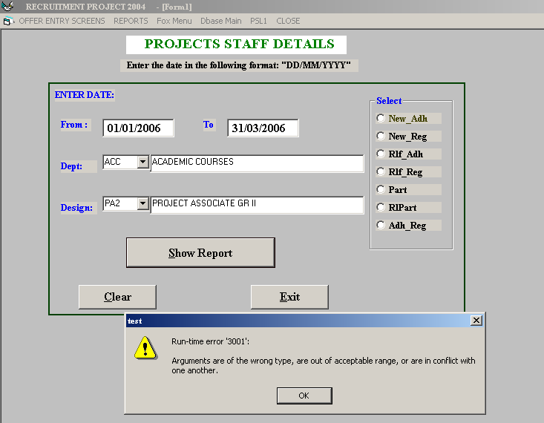
Figure 93: PSL1 - Query/Reports – Hospital Report – Total staff list (not able to get the report)

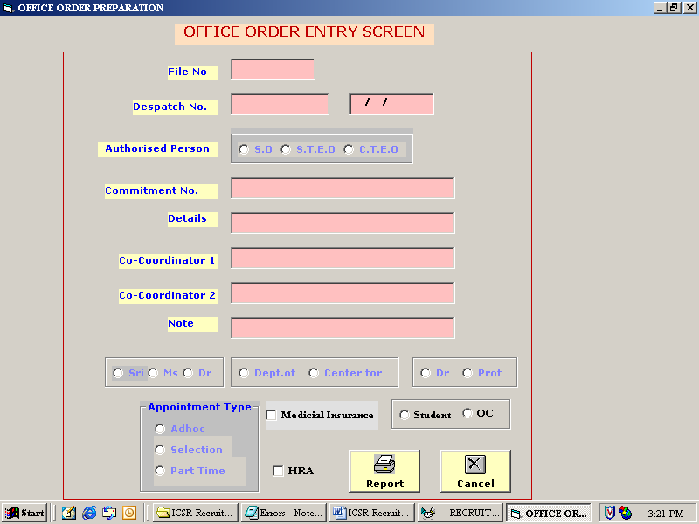
Figure 94: PSL1 – Office orders – Office order

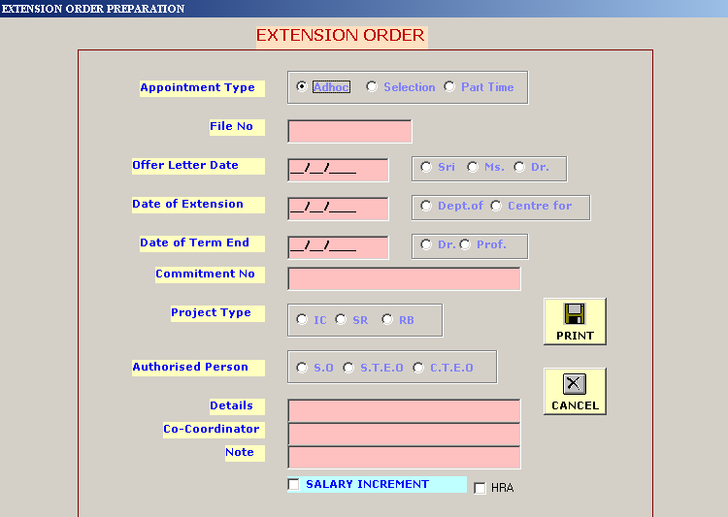
Figure 95: PSL1 – Office orders – Extension order

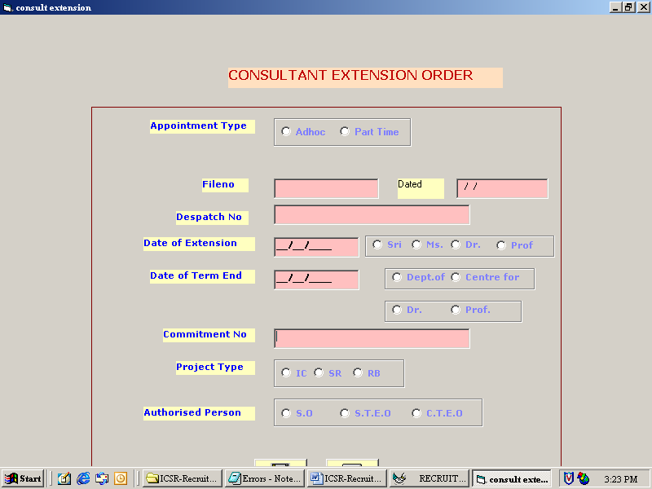
Figure 96: PSL1 – Office orders – Consult Extension order

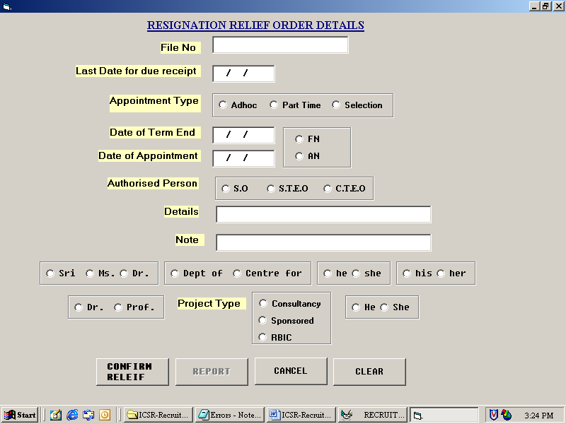
Figure 97: PSL1 – Office orders – Resignation relief

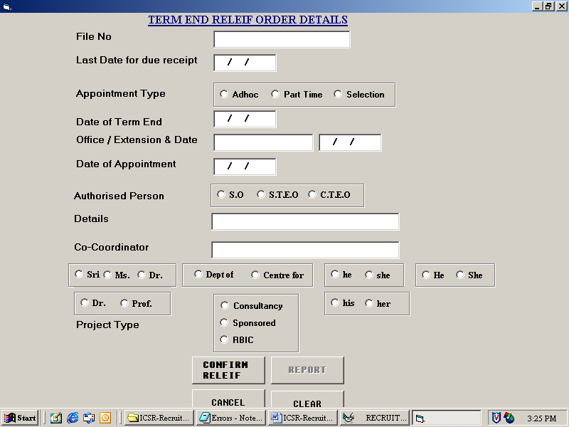
Figure 98: PSL1 – Office orders – Term and relief

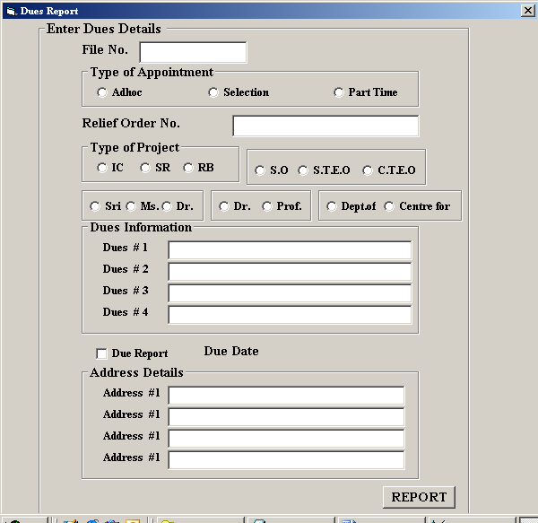
Figure 99: PSL1 – Office orders – Ondue detection

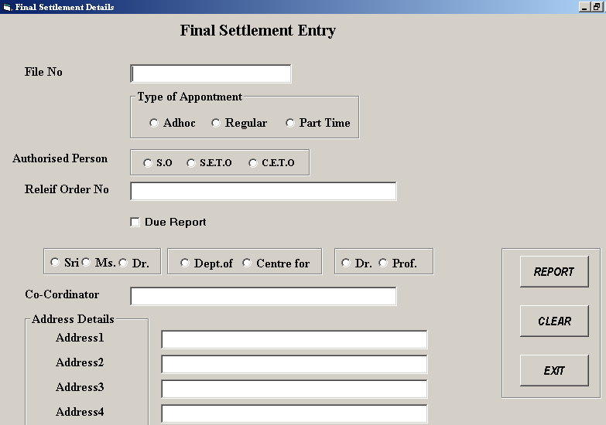
Figure 100: PSL1 – Office orders – Final Settlement

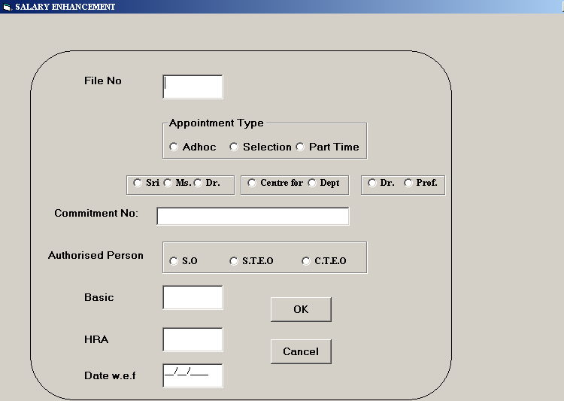
Figure 101: PSL1 – Office orders – Enhancement

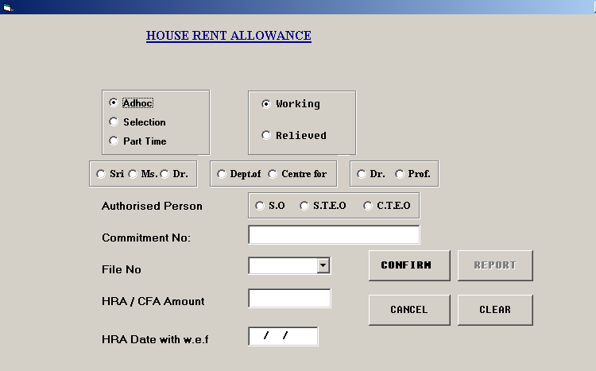
Figure 102: PSL1 – Office orders - HRA Order

Close

Exit
Logoff
Restart
Shutdown

